Enhancing Localized Weather Forecasting in Iloilo
Using Long Short-Term Memory (LSTM)

A Project
Presented to
The Faculty of College of Arts and Sciences
ILOILO SCIENCE AND TECHNOLOGY UNIVERSITY
La Paz, Iloilo City

In Partial Fulfillment
of the Requirements for the Degree
Bachelor of Science in Computer Science

Nethan Quinn G. Jael

Loi Marie Maxino

Aaron Hans L. Oliverio

Raymart John P. Patriarca

MARCH 2026

APPROVAL SHEET
The thesis entitled “Enhancing Localized Weather Forecasting in Iloilo Using Long Short-Term Memory (LSTM)” is prepared and submitted by Jael, Nethan Quinn G., Maxino, Loi Marie, Oliverio, Aaron Hans L., and Patriarca, Raymart John P. in partial fulfillment of the requirements for the degree BACHELOR OF SCIENCE IN COMPUTER SCIENCE, is hereby recommended for approval and acceptance.

LOVIDRICK JHON P. BARRIOS, MSCS
Adviser

It has passed the final defense on ____________, and was approved by the Research Committee on __________ with a grade of ___________.

PANEL OF EXAMINERS

MAUREEN NETIIE N. LINAN, DIT
Subject Professor

YVETTE G. GONZALES, D. Eng. JOYCE F. JAMILE, MSCS
Member Member

Accepted and approved in partial fulfillment of the requirements of the degree BACHELOR OF SCIENCE IN COMPUTER SCIENCE.

ERNEST ANDREIGH C. CENTINA, MSCS TRACY N. TACUBAN, DIT, Ph. D.
Head, Computer Science Department Dean, College of Computing and Informatics

Date: ______________________ Date: _______________________

ACKNOWLEDGEMENT
The researchers would like to express their sincere gratitude to all the individuals who contributed to the successful completion of this study.

First and foremost, the researchers would like to extend their deepest gratitude to the Almighty God for granting them wisdom, strength, and guidance throughout the entire process of completing this study.

The researchers would also like to express their heartfelt appreciation to Mr. Lovidrick Jhon P. Barrios, their Research Adviser and Consultant, for his expertise, patience, and continuous support. His valuable knowledge, guidance, and careful evaluation of the research papers greatly contributed to the development and successful completion of this research.

The researchers would also like to extend their sincere gratitude to Ma’am Maureen Nettie N. Linan, their Subject Adviser, for her academic support, guidance, and valuable insights that helped strengthen the study.

Special thanks are also extended to the respected panel members, Dr. Joyce F. Jamile and Dr. Yvette G. Gonzales, for their constructive feedback, insightful suggestions, and time devoted to reviewing the study. Their comments and recommendations significantly helped improve and refine this research.

The researchers would also like to express their deepest appreciation to their families for their unwavering love, encouragement, understanding, and moral support throughout the conduct of this research. Their constant motivation served as an inspiration for the researchers to persevere and complete this study.

The researchers are also grateful to their friends and classmates for their encouragement, cooperation, and support during the preparation of this research.

Finally, the researchers would like to express their appreciation to everyone who directly or indirectly contributed to the completion of this study.

To God be the Glory!

Nethan Quinn G. Jael
Loi Marie Maxino
Aaron Hans L. Oliverio
Raymart John P. Patriarca

ABSTRACT
This study developed and evaluated a localized weather forecasting model for Iloilo City using a Long Short-Term Memory (LSTM) neural network to improve short-term prediction of key meteorological parameters. Historical daily weather data (January 2014 to December 2024) were collected from the Open-Meteo API, including minimum and maximum temperature, rainfall amount, wind speed, relative humidity, dew point, and sunshine duration. Data preprocessing involved cleaning, targeted imputation of missing sunshine-duration values using time-based linear interpolation, Min-Max normalization, and time-series segmentation into fixed-length sequences to capture temporal dependencies.
A multivariate stacked LSTM architecture was implemented and trained using TensorFlow/Keras, with Adam as the optimizer and Mean Squared Error (MSE) as the loss function. To improve generalization and reduce overfitting, the study employed chronological data splitting, walk-forward validation (time-series cross-validation), Bayesian Optimization for hyperparameter tuning, and early stopping. Model performance was evaluated using Root Mean Squared Error (RMSE), Mean Absolute Error (MAE), and coefficient of determination (R²).
Results showed that the proposed LSTM model achieved moderate to strong predictive performance for localized multivariate weather forecasting, with an overall test performance of RMSE = 0.11991, MAE = 0.089216, and R² = 0.613322. The model performed best on smoother variables such as wind speed, relative humidity, and dew point, while rainfall and sunshine duration remained more difficult to predict due to their stochastic and event-driven behavior. The findings indicate that LSTM is a viable approach for localized weather forecasting
in Iloilo and can support applications in agriculture, disaster preparedness, and daily planning through more responsive and data-driven weather prediction.

TABLE OF CONTENTS
APPROVAL SHEET 1
ACKNOWLEDGEMENT 2
ABSTRACT 4
CHAPTER 1 1
INTRODUCTION 1
A. Background of the Study 1
B. Objectives of the Study 3
C. Conceptual Framework 4
D. Definition of Terms 6
E. Significance of the Study 15
F. Scope and Limitations of the Study 16
Chapter 2 18
REVIEW OF RELATED LITERATURE 18
Weather Forecasting 18
Key Parameters in Weather Forecasting 21
Weather in the Philippines 23
Time Series Forecasting 24
Data Imputation Methods in Time Series Forecasting 26
Traditional Weather Forecasting Methods 28
Applications of Machine Learning in Weather Forecasting 29
LSTM Model 32
LSTM in Weather Forecasting 35
LSTM Model Evaluation 38
Chapter 3 40
METHODOLOGY 40
A. Research Design 40
B. Data Collection 40
C. Data Preprocessing 40
D. Model Architecture 44
E. Training and Validation 47
F. Evaluation Metrics 52
G. Tools and Environment 53
Chapter 4 55
4.1 Collection and Preprocessing of Weather Data 55
4.2 Design of the LSTM Model 57
4.3 Training the LSTM Model on Meteorological Features 59
4.4 Evaluation of the LSTM Model’s Performance 60
Chapter 5 75
SUMMARY 75
CONCLUSION 77
References 80
APPENDICES 91
APPENDIX A 92
(CODE SNIPPETS) 92
APPENDIX B 98
(CURRICULUM VITAE) 98

LIST OF TABLES
Table 1. Open-Meteo Dataset. 42
Table 2. Normalized Weather Dataset. 44
Table 3. Final Model Architecture 58
Table 4a. Performance of the LSTM Model on Test Data (Horizon One) 60
Table 4b. Performance of the LSTM Model on Test Data (Horizon Two) 61

LIST OF FIGURES
Figure 1. Conceptual Framework for Localized Weather Forecasting in Iloilo Using Long Short-Term Memory (LSTM) Neural Networks. 4
Figure 2. RNN Structure. 34
Figure 3. LSTM Structure. 34
Figure 4. Linear Interpolation code snippet. 42
Figure 5. Time-Series Segmentation code snippet. 43
Figure 6. Linear Normalization code snippet. 44
Figure 7. LSTM Model Architecture for Weather Prediction. 46
Figure 8a. Model Creation Snippet. 47
Figure 8b. Continuation of Model Creation Snippet. 47
Figure 9a. Model Training code snippet. 48
Figure 9b. Continuation of Model Training code snippet. 49
Figure 10a. Cross Validation Class code snippet. 50
Figure 10b. Continuation Cross Validation Class code snippet. 50
Figure 10c. Continuation Cross Validation Class code snippet. 51
Figure 11. Historical Weather Data Visualization Table 56
Figure 12. Historical Weather Data Visualization Chart 57
Figure 13. Training vs. Validation Loss Curve 60
Figure 14a. Actual vs. Predicted Values for Rain Sum 66
Figure 14b. Actual vs. Predicted Values for Mean Relative Humidity 67
Figure 14c. Actual vs. Predicted Values for Sunshine Duration 68
Figure 14d. Actual vs. Predicted Values for Max Temperature 69
Figure 14e. Actual vs. Predicted Values for Min Temperature 70
Figure 14f. Actual vs. Predicted Values for Mean Wind Speed 71
Figure 14g. Actual vs. Predicted Values for Mean Dew Point 72
Figure 15. Predicted Weather Forecast on the Web-based Interface. 72

LIST OF EQUATIONS
Linear Interpolation (Equation 1) 27
R² (Equation 2) 38
MAE (Equation 3) 38
RMSE (Equation 4) 39

CHAPTER 1

INTRODUCTION

Background of the Study
Weather forecasting plays a crucial role in numerous sectors including agriculture, public safety, disaster preparedness, and daily planning. In the Philippines, the Philippine Atmospheric, Geophysical and Astronomical Services Administration (PAGASA) provides forecasts on weather conditions such as wind, precipitation, humidity, and temperature.
Forecasting in Iloilo presents challenges due to its tropical climate, leading to agricultural losses, public unpreparedness, and inefficient disaster responses. Typhoons and floods are prevalent in Iloilo [1]. The area has a monsoonal climate with distinct dry and wet seasons, and summer months from March to May [2].
Traditional forecasting methods, such as Numerical Weather Prediction (NWP), have served as standard approaches. These models solve complex mathematical equations using data from satellites, radars, and surface stations [3], [4]. However, numerical weather predictions are produced by global or regional numerical models, which often lack the resolution to capture localized conditions [5], such as Iloilo.
Alternative statistical models such as the Autoregressive Integrated Moving Average (ARIMA) have been utilized for time-series forecasting. While ARIMA is effective for identifying trends and seasonality in relatively stable data, it is less robust in the face of sudden weather shifts and requires significant effort to optimize [6], [7].
Additionally, methods like Convolutional Neural Networks (CNNs) have been applied to extract features from meteorological images, yet these demand high-quality labeled data and are susceptible to overfitting, particularly in small or unbalanced datasets [8].
Given these constraints, Long Short-Term Memory (LSTM) networks, a class of Recurrent Neural Networks (RNNs), have emerged as a more effective solution for weather prediction. LSTMs are designed to learn long-term dependencies in sequential data, making them ideal for modeling temporal meteorological patterns [9]. In a study by Xie et al. [10], LSTM models significantly reduced the root mean square error (RMSE) in weather prediction tasks compared to traditional methods.
Studies by Manandhar et al. [11] have also emphasized the importance of incorporating diverse weather variables such as temperature, rainfall, and humidity in rainfall detection, demonstrating the synergistic benefits of multivariate analysis in improving prediction accuracy. Similarly, Suhendra and Sutomo [12] explored the relationship between temperature and humidity on rainfall, reinforcing the relevance of these variables for localized forecasting.
Moreover, LSTM networks demonstrate greater flexibility in handling missing data and perform better in dynamic environments. As shown in the work of Taslim and Murwantara [13], while ARIMA had a slightly lower RMSE in some static datasets, LSTM achieved superior performance in volatile scenarios, demonstrating its suitability for complex weather patterns. Similarly, Liu and Yu [14] emphasized LSTM’s strength in managing multi-parameter input data and capturing temporal dependencies that static models often miss.
Considering Iloilo’s distinct climate and the limitations of existing forecasting tools, this study proposes the development of an LSTM-based weather prediction model. By leveraging several years of historical meteorological data specific to Iloilo, the model aims to provide short- to medium-term forecasts with improved accuracy. This approach has the potential to enhance resilience among agricultural stakeholders, improve disaster readiness, and provide more reliable forecasts for the general public.

Objectives of the Study
The study aims to develop a localized weather forecasting model using Long Short-Term Memory (LSTM) neural networks optimized for capturing complex nonlinear temporal patterns in Iloilo’s diverse meteorological data, aiming for improved localized weather prediction.
Specifically, this study aims to achieve the following:
- To collect and preprocess historical weather data specific to Iloilo for the past 10 years;
- To design an LSTM model capable of learning temporal dependencies in Iloilo’s historical weather data;
- To train the LSTM model using meteorological parameters such as humidity, minimum/maximum temperature, wind speed, sunshine, dew point, and rainfall amount as both input features and target outputs, enabling the model to learn and predict the next-day values of each parameter based on their historical data; and
- To evaluate the LSTM model using the Root Mean Squared Error (RMSE), Mean Absolute Error (MAE),and R-squared (R²) performance metrics.

Conceptual Framework
The researchers will adopt a structured framework composed of four interrelated components: Dataset, Data Processing, LSTM Model Training, and Output. Each component ensures reliability and applicability of the forecasting model within the specific local context.

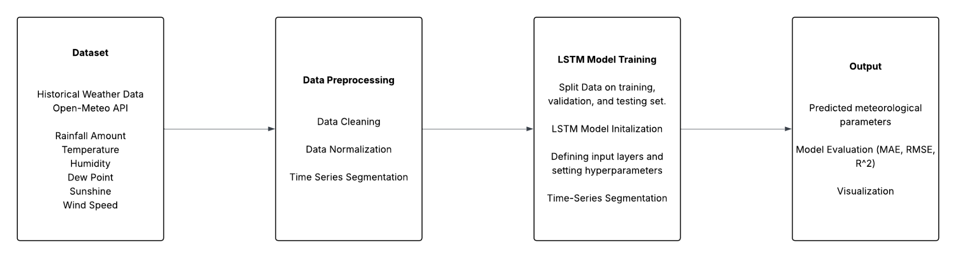
Figure 1. Conceptual Framework for Localized Weather Forecasting in Iloilo Using Long Short-Term Memory (LSTM) Neural Networks.
Dataset
The initial phase will involve the collection of localized historical weather data of Iloilo sourced from the Open-Meteo API, an open-access meteorological database. The researchers will gather data for essential weather parameters, including temperature, dew point, sunshine, rainfall amount, humidity, and wind speed. These variables will be crucial for weather forecasting, offering a comprehensive representation of local climatic conditions and valuable insights into Iloilo's climate trends.

Data Preprocessing
With the acquired raw datasets from Open-Meteo, the data will first undergo a cleaning process. Data cleaning addresses issues such as missing values and non-numerical data, ensuring consistency and completeness throughout the dataset. Afterwards, normalization will be applied to standardize the data, scaling the values between 0 and 1 to improve efficiency during the training process and reduce the risk of overfitting. Finally, the preprocessed data will be segmented into time-series sequences, enabling the model to learn from patterns over the ten years of historical weather data. This phase ensures that the data is accurate, standardized, and formatted appropriately for the subsequent modeling tasks.

LSTM Model Training
The preprocessed data will be used to train the LSTM model following a systematic data splitting and validation strategy. The dataset will be divided into a training set (80%), a validation set (20% of the training set), and a separate hold-out test set (20%) for final and unbiased model evaluation. During the model development and training phase, walk-forward validation will be applied exclusively to the training and validation sets to fine-tune hyperparameters and evaluate generalization capabilities. This approach ensures that the temporal order of the data is preserved, making the validation process more suitable for time-series forecasting.
The LSTM model will be initialized and configured with particular attention to the structure of its input layers and the selection of hyperparameters. The segmented time-series data will be used to train the model, enabling it to capture temporal dependencies and nonlinear patterns within the meteorological data. Early stopping will be implemented based on the performance on the validation set during walk-forward validation to prevent overfitting.

Output
The final component of the framework involves generating and evaluating the output of the LSTM model. The trained LSTM model produces predictions of meteorological parameters, which are then assessed using evaluation metrics such as RMSE, MAE, and R². Additionally, the results are visualized for easier comprehension and clear comparisons between the predicted and actual weather values.

Definition of Terms
Philippine Atmospheric, Geophysical, and Astronomical Services Administration (PAGASA). The national agency responsible for weather forecasting in the Philippines [15].
PAGASA provides valuable meteorological insights that help contextualize local weather patterns.
Open-Meteo API. An open-access weather data service that provides free, real-time and historical weather data through a programmatic interface [16].
Open-Meteo API will serve as the primary source of historical weather data required for training and testing the proposed LSTM model.
Numerical Weather Prediction (NWP). A method of weather forecasting that employs a set of equations that describe the flow of fluids [4].
NWP models represent traditional forecasting methods used for example, by PAGASA, for comparison with the LSTM-based model.
Forecasting. A scientific estimate of future weather conditions. Weather condition is the state of the atmosphere at a given time expressed in terms of the most significant weather variables [17].
Forecasting serves as the foundation of the study, enabling the prediction of localized weather conditions through the use of machine learning models like LSTM.
Over-fitting. Occurs when a machine learning model learns patterns too specific to the training data, often due to insufficient data size or the presence of noisy, irrelevant information [18].
In this study, overfitting is highlighted as a critical challenge in developing accurate weather forecasting models, underscoring the need for effective techniques to enhance model generalization and robustness.
Auto Regressive Integrated Moving Average (ARIMA). A technique for time series analysis and for forecasting possible future values of a time series [19].
ARIMA is used in this study as a baseline model to compare the performance of the proposed LSTM-based weather forecasting approach.
Long Short-Term Memory (LSTM). A type of recurrent neural network (RNN) architecture designed to handle the vanishing gradient problem, which often occurs in traditional RNNs. It is particularly well-suited for processing sequences of data, such as time series, text, or speech [20].
LSTM serves as the primary architecture for developing a localized weather prediction model for Iloilo City.
Temperature. Describes how hot or cold the atmosphere is [21].
In this study, temperature is one of the meteorological parameters analyzed and predicted using the LSTM model.
Rainfall Amount. Refers to the total amount of liquid or melted solid precipitation that falls on a ground surface over a specific period, typically 12 or 24 hours. It is a measure of the depth of water that accumulates on a horizontal surface after all evaporation, percolation, and runoff have been accounted for [22].
In this study, rainfall amount is a key output parameter for the LSTM-based weather prediction model.
Humidity. The amount of water vapor actually in the air, expressed as a percentage of the maximum amount of water vapor the air can hold at the same temperature [23].
In this study, humidity is included as a critical input variable for predicting weather conditions.
Dew Point. Refers to the temperature at which air needs to be cooled for the water vapor it contains to condense into liquid water or frost [24].
In this study, the dew point is analyzed as a critical meteorological parameter influencing weather forecasting accuracy.
Sunshine. Direct radiation from the sun, as opposed to the shading of a location by clouds or by other obstructions [25].
In this study, sunshine is considered an essential parameter for analyzing and forecasting weather patterns.
Wind speed. The movement of air whose speed and direction influence environmental conditions [26].
In this study, wind speed is considered a key meteorological parameter.
RMSE (Root Mean Squared Error). The measure of the differences between values that are predicted by a model and values that are actually observed. Generally, the smaller this value generated by a model, the more accurate that model is in predicting the measured values [27].
In this study, RMSE will be used as a performance metric to evaluate the accuracy of the LSTM model's predictions.
MAE (Mean Absolute Error). A metric that calculates the average magnitude of the absolute errors between the predicted and actual values [28].
In this study, MAE serves as an additional metric to assess the performance of the LSTM-based weather prediction model.
R² (R-squared). Measures the proportion of variance for a dependent variable that is explained by the independent variables in a regression model. It can also be thought of as a measure of goodness of fit, or how well data fits the regression model. An R-squared value ranges from 0 to 1, where 1 indicates a perfect model fit and 0 indicates no model fit [29].
In this study, R² will be used to evaluate how well the LSTM model fits the weather data.
Time Series Data. Collection of data points gathered over a period of time and ordered chronologically [30].
In this study, time series data refers to the historical meteorological records that will be used as input for the LSTM model.
Normalization. A specific form of feature scaling that standardizes the range of features, ensuring they fall within a common scale. It is a vital step in data preprocessing that ensures uniformity of the numerical magnitudes of features. This uniformity avoids the domination of features that have larger values compared to the other features or variables [31].
In this study, normalization will be applied during data preprocessing to ensure optimal training of the LSTM model.
Linear Interpolation. A data imputation technique used to estimate missing values by assuming a straight-line change between known data points over time [32].
In this study, linear interpolation was used during data preprocessing to estimate missing weather values (particularly time-indexed values) before model training.
Min-Max Scaling. A specific normalization technique that rescales each feature to a fixed range, commonly between 0 and 1, while preserving the relative relationships among values [33].
In this study, Min-Max Scaling was applied to meteorological variables to place all features on a common scale and support stable LSTM training.
Time-Series Segmentation (Sliding Window). A preprocessing technique that converts chronological data into overlapping input-output sequences (windows) for supervised learning [34].
In this study, time-series segmentation was used to transform daily weather records into fixed-length sequences that served as inputs to the LSTM model.
Hyperparameter. A configuration value set before training that controls the model structure or learning process and is not directly learned from the data [35].
In this study, hyperparameters included LSTM units, Dense layer units, dropout rate, regularization values, and learning rate.
Hyperparameter Tuning. The process of selecting the best hyperparameter values to improve model performance on a validation criterion [36].
In this study, hyperparameter tuning was performed to identify the best LSTM architecture and training settings for localized weather forecasting.
Bayesian Optimization. A model-based hyperparameter search method that uses prior trial results to intelligently select promising parameter combinations for subsequent trials [37].
In this study, Bayesian Optimization was used to tune the LSTM model’s hyperparameters efficiently based on validation loss.
Adam Optimizer (Adaptive Moment Estimation). A first-order gradient-based optimization algorithm that adaptively adjusts learning updates using estimates of first and second moments of the gradients [38].
In this study, Adam was used as the optimizer for training the LSTM model due to its efficiency and strong empirical performance in deep learning tasks.
Learning Rate. A training hyperparameter that determines the size of weight updates applied by the optimizer during model training [39].
In this study, the learning rate of the Adam optimizer was tuned to achieve stable convergence and improve forecasting performance.
Dropout. A regularization technique that randomly sets a fraction of neural network units to zero during training to reduce overfitting [40].
In this study, dropout layers were used between LSTM and Dense layers to improve model generalization.
Dense Layer (Fully Connected Layer). A neural network layer in which each neuron receives input from all outputs of the previous layer and applies a weighted transformation with an optional activation function [41].
In this study, Dense layers were used after the LSTM layers to refine learned temporal representations and generate the final weather parameter outputs.
ReLU (Rectified Linear Unit). An activation function that outputs the input directly when it is positive and outputs zero otherwise [42].
In this study, ReLU was used in Dense layers to introduce nonlinearity and improve the model’s ability to learn complex relationships in weather data.
Loss Function. A function that computes the quantity the model aims to minimize during training in order to improve prediction accuracy [43].
In this study, the loss function guided parameter updates during LSTM training and was used as the optimization objective.
Mean Squared Error (MSE). A regression loss that computes the mean of the squared differences between predicted and actual values [44].
In this study, MSE was used as the training loss function for the LSTM model.
Early Stopping. A training control technique that halts training when a monitored metric (e.g., validation loss) stops improving, helping prevent overfitting [45].
In this study, early stopping was used to stop training when further epochs no longer improved model performance.
Validation Set. A subset of data reserved during training for evaluating model performance at the end of each epoch and guiding model selection/tuning, but not used to update model weights [46].
Batch Size. The number of training samples processed before a gradient update is performed during one training step [46].
In this study, batch size was specified as a training hyperparameter during model fitting.

Epoch. One complete iteration over the entire training dataset during the model training process [46].
In this study, the LSTM model was trained for a specified number of epochs, subject to early stopping based on validation performance.
In this study, the validation set was used during hyperparameter tuning and training to monitor loss and support early stopping.
Test Set (Hold-out Test Set). A reserved subset of data used only for final model evaluation after training and tuning are completed [47].
In this study, the test set was used to assess the final forecasting performance of the trained LSTM model using RMSE, MAE, and R².
Cross-Validation. A model evaluation approach that estimates generalization performance by repeatedly splitting data into training and validation/test portions under a defined scheme [48].
In this study, a time-series-aware cross-validation strategy was used instead of random splitting to preserve chronological order.
Walk-Forward Validation. A time-series validation method in which training data expands over successive splits while evaluation is performed on the next chronological segment [49].
In this study, walk-forward validation was used to evaluate the LSTM model in a manner consistent with real-world forecasting conditions.
Data Leakage. A modeling issue that occurs when information unavailable at prediction time is inadvertently used during model building or evaluation, leading to overly optimistic results [50].
In this study, data leakage was minimized by preserving chronological order in splitting and evaluation procedures.
Regularization. A set of techniques that add constraints or penalties during training to reduce overfitting and improve generalization [51].
In this study, regularization was incorporated in the model to help control overfitting during LSTM training.
L2 Regularization. A regularization method that adds a penalty proportional to the squared magnitude of model weights to the loss function [52].
In this study, L2 regularization was applied to selected layers as part of hyperparameter tuning to improve model robustness.

Significance of the Study
This study holds significant value in the fields of agriculture, technology, and environmental science by showcasing the potential of Long Short-Term Memory (LSTM) models in enhancing the accuracy of localized weather forecasting, specifically for Iloilo.
Farmers and Agricultural Planners. This study will provide farmers and agricultural planners with accurate, localized weather forecasts, helping them make better decisions regarding crop cycles, irrigation, and fertilizer application, which can lead to improved yields and reduced losses.
Local Government Units (LGUs). This study will help LGUs in Iloilo enhance disaster preparedness, respond effectively to extreme weather, and make informed decisions on class suspensions to ensure community safety.
General Public. The results of this study will benefit the general public by offering improved weather forecasts, allowing individuals to plan daily activities such as travel, events, and outdoor activities with greater confidence.
Researchers and Developers. The researchers and developers in the fields of computer science and environmental technology may benefit from this work as it contributes to the growing body of knowledge on AI applications in weather prediction, offering a model that could be adapted to other locations, weather parameters, and use cases.

Scope and Limitations of the Study
This study focuses on enhancing localized weather forecasting in Iloilo using Long Short-Term Memory (LSTM), a type of recurrent neural network model designed for sequential data. The development of the forecasting model aims to improve the prediction accuracy of key meteorological parameters, including rainfall, temperature, humidity, wind speed, sunrise, and dewpoint. The scope of the study includes the collection and preprocessing of historical weather data gathered exclusively from the Open-Meteo API.
The study will be conducted from March 2025 to December 2025 at Iloilo Science and Technology University - Main Campus. The forecasting model will be developed and tested using Python and relevant machine learning libraries, and its evaluation will be based on standard performance metrics such as Root Mean Square Error (RMSE), Mean Absolute Error (MAE), and R-squared (R²).
The study will address missing or incomplete data within the Open-Meteo dataset by employing linear interpolation.
The study is delimited to the implementation of LSTM models only and does not explore other deep learning architectures. Broader external factors influencing weather conditions, such as long-term climate change trends, regional air pollution, or global atmospheric phenomena (e.g., El Niño or La Niña), are beyond the scope of this study.

Chapter 2

REVIEW OF RELATED LITERATURE
Localized weather forecasting is crucial for regions like Iloilo, where microclimatic conditions can significantly impact agriculture, disaster preparedness, and daily life. By leveraging machine learning models such as Long Short-Term Memory (LSTM) neural networks, this study seeks to address the limitations of traditional forecasting methods. A literature review is vital to establish the foundation for this research, providing context, identifying gaps, and aligning the study with existing knowledge.

Weather Forecasting
Related Literature
Weather forecasting is the process of predicting atmospheric conditions at a specific location over a given period. This practice is essential in modern society, as it influences various sectors and impacts daily life significantly. The importance of weather forecasting can be observed across multiple industries, each relying on accurate predictions to enhance safety, efficiency, and decision-making [53].
In agriculture, weather forecasting significantly influences crop production and farm management. Accurate predictions allow farmers to make informed decisions about planting, irrigation, and harvesting. For example, understanding rainfall patterns helps determine the best time to sow seeds, ensuring crops receive necessary moisture during critical growth phases. Additionally, forecasts can warn farmers of severe weather events, enabling them to take protective measures. The economic impact of weather forecasting is particularly notable in agriculture. Research indicates that improving forecast accuracy can lead to a 2-3% increase in agricultural output for every 1% improvement in accuracy. This boost not only enhances farmers' incomes but also contributes to food security and sustainable economic growth. Moreover, accurate forecasts aid in resource management. Farmers can optimize irrigation schedules based on predicted rainfall, conserving water and reducing costs. Timely weather information also assists in pest and disease management, as certain conditions can trigger outbreaks. By anticipating these situations, farmers can implement control measures proactively, minimizing crop losses [54].
Furthermore, advancements in information technology have transformed weather forecasting, enhancing its accuracy and reliability. The use of cloud computing allows meteorologists to manage extensive meteorological data effectively, leading to more precise forecasting models. Artificial intelligence (AI) and machine learning (ML) have become essential in analyzing large datasets, enabling the identification of complex patterns that improve forecast accuracy. These technologies help meteorologists refine their models and adapt to changing weather conditions swiftly. Additionally, advanced data visualization techniques ensure that critical weather information is communicated effectively to end-users, making it accessible and understandable [55].

Related Studies
In addition to theoretical and technological developments, various studies have demonstrated the practical applications and socio-economic importance of weather forecasting. For instance, Mohapatra [56] emphasized that weather forecasting plays a crucial role in disaster preparedness and response, particularly in regions prone to natural disasters like India, where about 80% of such events are hydro-meteorological in nature. Accurate weather predictions enable authorities to conduct hazard analysis and vulnerability assessments, which are essential steps in risk management. Recent advancements in multi-hazard monitoring and warning systems, driven by initiatives from the Ministry of Earth Sciences, have improved the accuracy and reliability of forecasts. However, there remains significant room for improvement, particularly at the state and district levels, where enhancing mesoscale hazard detection and communication to disaster managers is essential. This highlights the global recognition of the importance of weather forecasting in mitigating the impacts of disasters. By focusing on improving prediction skills, information dissemination mechanisms, and the socio-economic impacts of extreme weather events, communities can better prepare for and respond to disasters, ultimately saving lives and reducing economic losses.
Furthermore, advancements in information technology have transformed weather forecasting, enhancing its accuracy and reliability. The use of cloud computing allows meteorologists to manage extensive meteorological data effectively, leading to more precise forecasting models. Artificial intelligence (AI) and machine learning (ML) have become essential in analyzing large datasets, enabling the identification of complex patterns that improve forecast accuracy. These technologies help meteorologists refine their models and adapt to changing weather conditions swiftly. Additionally, advanced data visualization techniques ensure that critical weather information is communicated effectively to end-users, making it accessible and understandable.
Therefore, the researchers recognize that improving forecast accuracy through advanced technologies and localized data is essential for enhancing weather prediction reliability. By integrating meteorological progress, economic impacts, disaster preparedness insights, and modern IT tools, the study aims to develop a forecasting model tailored to Iloilo’s specific needs. This approach supports more effective agricultural planning, disaster risk reduction, and timely information dissemination in a region vulnerable to hydro-meteorological hazards.

Key Parameters in Weather Forecasting
Related Literature
Weather forecasting is an intricate task shaped by a multitude of meteorological parameters, such as atmospheric pressure, wind speed, and solar radiation. However, not all parameters contribute equally to accurate predictions. Only a few critical variables significantly influence weather patterns, and incorporating every available parameter into forecasting models can lead to overfitting—where the model becomes overly complex, capturing noise rather than meaningful patterns. This approach can reduce model accuracy, introduce unnecessary computational overhead, and impair the model's ability to generalize effectively. As such, it is vital to carefully select and focus on impactful parameters to create efficient and reliable forecasting models [57].

Related Studies
In line with this, Shekana et al. [58], conducted a study on the Ethiopian Dodota Woreda region, an area severely affected by recurrent droughts, emphasizing the importance of identifying key meteorological parameters to improve weather variability forecasting. Their research initially examined 20 meteorological parameters, but through feature selection techniques and expert validation, narrowed the focus to six key parameters: temperature, dew point, sunshine, rainfall, wind speed, and relative humidity These six were found to have the highest information gain and were deemed sufficient to accurately predict weather conditions, achieving strong positive relationships with weather forecasting in meteorology sectors, significantly contributing to the accuracy of predictive models.
Using the Multilayer Perceptron (MLP) algorithm, their predictive model achieved an impressive accuracy of 98.39% in correctly classified instances, highlighting the effectiveness of the selected parameters and modeling approach.
Building on these findings, the researchers will also use these carefully selected parameters to further validate their effectiveness and enhance the reliability and precision of the weather prediction model.

Weather in the Philippines
Related Literature
The Philippines has a tropical and maritime climate, characterized by high temperatures, elevated humidity, and abundant rainfall throughout the year. The average annual temperature is approximately 26.6°C, with cooler months around January and peak heat in May. Due to the country's geographical setting, humidity remains high, ranging from 71% to 85%, contributing to a high heat index especially during the dry months.
Rainfall is unevenly distributed across regions, with annual totals ranging from 965 mm to over 4,000 mm depending on topography and prevailing wind patterns. The Philippine climate is divided into two major seasons: the rainy season from June to November, and the dry season from December to May, which is further classified into cool and hot dry periods. Based on rainfall distribution, PAGASA identifies four climate types, reflecting the geographic diversity in weather conditions across the archipelago.
Furthermore, the country is highly vulnerable to typhoons, averaging about 20 per year, many of which influence rainfall patterns and pose significant risks to infrastructure and agriculture. [59]

Related Studies
Several empirical studies have investigated the climatic behavior and projected weather trends across the Philippines. Cinco et al. [70] analyzed long-term temperature and rainfall data from 1951 to 2010, revealing a general warming trend characterized by increasing nighttime temperatures and more frequent extreme rainfall events. These results demonstrate the growing importance of adaptive forecasting techniques that can capture nonlinear patterns in tropical climates.
Similarly, Villafuerte et al. [61] utilized multiple dynamical downscaling models to project future changes in temperature and rainfall across the Philippines. The study found that mean temperatures are expected to rise by approximately 1.2°C to 2.3°C by the mid-21st century, while rainfall intensity, particularly during the southwest monsoon season, is projected to increase.
Thus, the researchers selected relative humidity, temperature, and rainfall amount as the primary input parameters for the prediction model, as these variables are the most significant contributors to the climatic behavior of the Philippines. Given the country's tropical and maritime setting—characterized by persistent heat, high moisture levels, and frequent precipitation—these elements are not only foundational to daily weather fluctuations but also critical in long-term climate forecasting

Time Series Forecasting
Related Literature
Time series forecasting is a vital area of data analysis that plays a significant role in various fields, including finance, economics, weather prediction, and industrial processes. The primary goal of time series forecasting is to predict future values based on previously observed data points. Historically, traditional forecasting methods have been limited in their ability to capture the complex patterns and dynamics inherent in real-world time series data. These classical techniques often rely on linear models, such as the Autoregressive Integrated Moving Average (ARIMA) and Exponential Smoothing methods, which may not adequately represent the underlying nonlinear relationships in the data [62], [63].
As a response to these limitations, modern forecasting methods have emerged, particularly those leveraging machine learning and deep learning techniques. Among these, Long Short-Term Memory (LSTM) networks and Recurrent Neural Networks (RNNs) have gained prominence due to their effectiveness in capturing intricate temporal dependencies within data sequences [64]. These advanced models are designed to handle the sequential nature of time series data, allowing them to learn both short- and long-term dependencies, making them particularly suitable for forecasting tasks. The review by Kolambe and Arora [62] synthesizes key advancements in the field, discussing the strengths and limitations of various approaches, and emphasizes the growing importance of hybrid and data-driven methods in achieving higher forecasting accuracy.
Related Studies
Recent studies have demonstrated the superiority of deep learning approaches compared to traditional statistical forecasting models. Hewamalage et al. [65] conducted a comprehensive evaluation of Recurrent Neural Network architectures, concluding that LSTM-based models outperform conventional approaches such as ARIMA when handling nonlinear and nonstationary time series data. Similarly, Lim and Zohren [66] reviewed a wide range of deep learning architectures, including attention-based and convolutional variants, highlighting their effectiveness in capturing long-term temporal dependencies and reducing forecast errors across various domains.
Therefore, the researchers emphasize the importance of employing advanced time series forecasting methods, such as LSTM and RNN models, to effectively capture the complex temporal patterns that traditional linear models often miss. These deep learning techniques offer enhanced capabilities in modeling sequential data, making them well-suited for accurate weather prediction. This foundation supports the study’s aim to leverage LSTM networks for improved forecasting performance in the dynamic climate context of Iloilo.

Data Imputation Methods in Time Series Forecasting
Related Literature
Handling missing values is vital in time-series data analysis due to its impact on temporal dependencies and model accuracy. Various methods address this issue, including deletion, which risks significant data loss, and imputation techniques like constant, mean, median, or mode substitution, which may distort data distribution or underestimate variance. Time-series-specific methods such as LOCF, NOCB, and rolling statistics better preserve temporal patterns but can introduce bias or require careful tuning. Advanced techniques like spline interpolation and KNN capture complex patterns but are resource-intensive. Linear interpolation, however, balances simplicity and effectiveness by estimating missing values based on a linear relationship between neighboring points, maintaining temporal trends and continuity, making it a reliable choice for time-series datasets [67]. The formula for linear interpolation, shown in Equation 1, calculates missing values where $x_{1}$​ and $y_{1}$​ are the first coordinates, $x_{2}$​ and $y_{2}$​ are the second coordinates, $x_{}$is the point to perform the interpolation, and $y$ is the interpolated value.

Related Studies
Gore et al. [68] highlighted the practical utility of linear interpolation in weather analysis, demonstrating its superior accuracy compared to other methods like cubic and spline interpolation. Their study reports that linear interpolation achieved an accuracy of 90.92% in rainfall predictions, outperforming other imputation techniques and proving vital for agricultural planning in India’s drought-prone Marathwada region.
Building on these insights, the researchers will adopt linear interpolation as the primary method for handling missing weather data in their study. This decision is driven by its ability to maintain temporal trends and provide reliable estimates, ensuring the dataset's consistency and accuracy.

$Linear Interpolation (y) =y_{1}+\frac{(x - x_{1})(y_{2} -{ y}_{1} ) }{x_{2} - x_{1}}$ (1)

Traditional Weather Forecasting Methods
Related Literature
Numerical Weather Prediction (NWP), as described by Kalnay [69], is considered the standard for large-scale weather forecasting. These models solve partial differential equations based on fundamental physical laws and incorporate a wide array of data sources, including satellites, radars, and surface stations. While NWP models are highly effective for providing general weather forecasts, their coarse resolution can limit their ability to capture more localized weather phenomena. For instance, the Philippine Atmospheric, Geophysical, and Astronomical Services Administration (PAGASA) primarily depends on Numerical Weather Prediction (NWP) for its forecasting efforts. However, as noted by Rabier [70], they frequently face challenges due to the intricate nature of atmospheric processes and the significant computational power required.
In contrast, statistical models like the Autoregressive Integrated Moving Average (ARIMA) are widely used for time-series forecasting. According to Saadeddin [71], ARIMA is effective at detecting trends and seasonality within data, making it a useful tool for predicting weather patterns over time. However, ARIMA struggles with capturing abrupt changes in data, which is a critical challenge in weather forecasting, especially when there are sudden shifts in weather conditions.

Related Studies
Taslim and Murwantara [13] note that ARIMA has limitations when dealing with multivariate datasets, which are often encountered in weather forecasting, where multiple variables need to be considered simultaneously to make accurate predictions.
In recent years, Convolutional Neural Networks (CNN) have emerged as a promising tool in weather forecasting, particularly for spatial pattern recognition. CNNs are particularly effective at analyzing large datasets, such as satellite images or weather radar data, where patterns in the data are spatially correlated. According to Zhang et al. [72], CNNs excel at identifying complex spatial features that traditional methods might miss, making them ideal for applications like storm tracking or identifying atmospheric patterns. Unlike NWP or ARIMA, CNNs can handle high-dimensional data and automatically learn relevant features without the need for manual feature engineering. However, while CNNs can provide more detailed and precise predictions, they require large amounts of labeled data for training, which can be a limitation in weather forecasting, where high-quality labeled data may not always be available.

Applications of Machine Learning in Weather Forecasting
Related Literature
Machine learning (ML) has significantly transformed weather forecasting by enhancing the accuracy and efficiency of predictions across various sectors, including agriculture, transportation, and energy [73]. Traditional forecasting methods, primarily based on Numerical Weather Prediction (NWP), often struggle with the complexities of atmospheric processes and require substantial computational resources [70]. In recent years, ML, especially deep learning, has gained prominence for its ability to process massive datasets, extract spatial–temporal patterns, and improve model resolution and predictive performance [72].
ML techniques such as Support Vector Machines (SVM), Random Forests (RF), and deep learning models like Convolutional Neural Networks (CNNs) and Recurrent Neural Networks (RNNs) are particularly well-suited to handling large, high-dimensional datasets. These models excel at identifying intricate patterns that traditional models often miss [74]. Innovations such as GenCast, a probabilistic forecasting system, have further advanced the field by generating ensemble predictions that offer a range of possible weather outcomes. This is crucial for managing uncertainty in extreme weather scenarios [75].
Hybrid approaches are also gaining traction. Institutions such as the European Centre for Medium-Range Weather Forecasts (ECMWF) are exploring ways to combine ML with NWP methods, using ML for tasks such as data assimilation and model output correction. These integrations aim to enhance the accuracy of forecasts while reducing computational costs [70]. Despite these advances, challenges remain. These include the interpretability of complex ML models and their difficulty in predicting rare but critical weather events [72].
The Philippines, a country highly vulnerable to climate variability, is beginning to harness the potential of ML in localized weather forecasting. Several recent studies demonstrate how ML is being applied to improve predictive accuracy for specific weather variables across different regions.

Related Studies
Cruz et al. [76] developed a predictive model for maximum temperature forecasting in Manila and Dagupan. Their approach combined standard scaling for normalization, principal component analysis (PCA) for dimensionality reduction, regression models to define relationships, and time-series analysis to account for temporal dynamics. This multi-method pipeline successfully addressed challenges posed by the dataset’s 32 predictors, demonstrating the benefits of integrating various ML techniques in climate modeling.
In a related effort, Lagrazon et al. [77] conducted a comparative analysis of ML models for rainfall prediction in Cavite Province. The study evaluated Decision Trees, SVM, Gaussian Process Regression, Ensemble Methods, and Neural Networks. All models demonstrated strong performance, emphasizing the adaptability of ML for precipitation forecasting in localized settings. Similarly, Namok and Luzano [78] utilized ARIMA, SARIMA, and Artificial Neural Networks (ANNs) to analyze and forecast rainfall trends in the Southern Philippines, reinforcing the efficacy of data-driven approaches for regional climate research.
Ruaro and So [79] applied ensemble regression models, specifically Random Forest and Gradient Tree Boosting, to predict weather trends in Makati, Cebu, and Iloilo using historical data from December 2021 to March 2022. Their findings highlighted the strength of ensemble techniques in capturing complex weather patterns across diverse urban locations.
This study builds upon their research by integrating a broader set of meteorological parameters, including humidity, wind speed, sunshine, and dew point, and focusing specifically on Iloilo. By addressing these critical factors, this study aims to enhance the accuracy and relevance of localized weather predictions while contributing valuable insights to regional climate research.
Overall, the application of LSTM in this study represents a novel approach to forecasting in Iloilo, emphasizing its potential to improve resilience against climate variability. The continued evolution of machine learning in weather forecasting paves the way for more reliable and timely predictions, benefiting regional research efforts and industries reliant on precise weather information.

LSTM Model
Related Literature
Long Short-Term Memory (LSTM) networks are a type of Recurrent Neural Network (RNN) designed to retain long-term dependencies in sequential data. LSTMs excel in processing and analyzing sequential information, such as time series, text, and speech. They utilize memory cells and gating mechanisms to manage the flow of information, enabling selective retention or discarding of data. This approach effectively mitigates the vanishing gradient problem commonly associated with traditional RNNs. LSTMs find applications in various domains, including natural language processing, speech recognition, and time series forecasting [80].
An LSTM memory cell is more sophisticated than a conventional RNN unit. While a standard RNN primarily uses a single activation function, an LSTM integrates multiple nonlinear functions,sigmoid and tanh, across its internal gates to control information passage. As shown in Figure 2, a standard RNN module passes information sequentially without the ability to manage memory effectively. In contrast, Figure 3 illustrates the structure of an LSTM module, which includes three gates, the input gate, forget gate, and output gate, along with a cell state that maintains long-term context. The forget gate determines which past information to discard, the input gate regulates which new data to store, and the output gate controls what portion of the updated cell state becomes the new hidden state. Together, these mechanisms enable LSTMs to learn temporal dependencies more efficiently and with greater precision.

Related Studies
LSTM networks have proven to be highly effective in various real-world forecasting tasks, particularly in meteorological prediction. Khan et al. [81] implemented LSTM-based Recurrent Neural Networks to predict temperature and rainfall patterns in Bangladesh. Their study demonstrated that LSTMs outperformed traditional statistical models in both short- and long-term forecasting scenarios, achieving higher accuracy and lower mean absolute error. The model’s capacity to capture nonlinear dependencies and seasonal variations in climate data underscores its suitability for weather forecasting applications.

Therefore, researchers recognize the versatility and efficacy of LSTM networks in handling complex sequential data, particularly in weather prediction. Due to their ability to model and understand temporal patterns in time series data, LSTMs are well-suited for predicting weather patterns based on historical meteorological data.

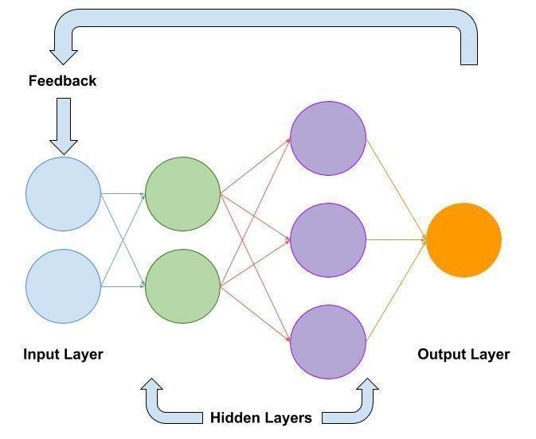

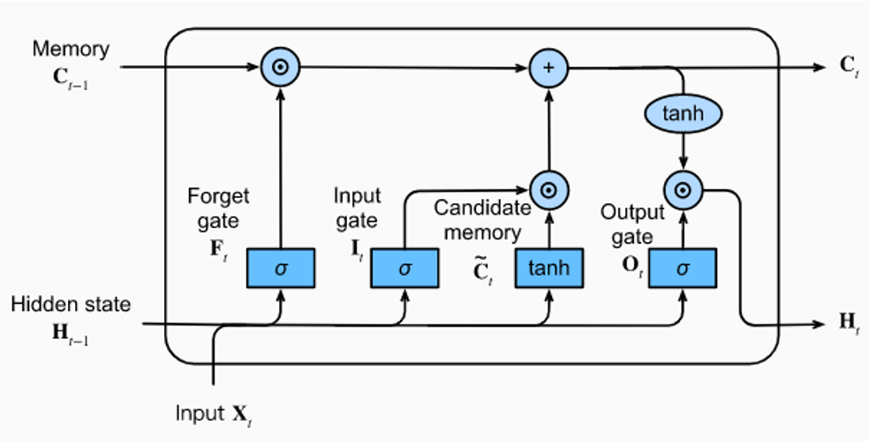
Figure 2. RNN Structure.

Figure 3. LSTM Structure.

LSTM in Weather Forecasting
Related Literature
Long Short-Term Memory (LSTM) networks have emerged as a powerful tool in weather forecasting due to their ability to model complex temporal dependencies in sequential data. LSTMs, a specialized type of recurrent neural network (RNN), address the vanishing gradient problem that limits traditional RNNs, making them particularly suitable for capturing long-term patterns. Recent studies have demonstrated the effectiveness of LSTM models in various meteorological tasks. Sarwade et al. [82] emphasized LSTM’s strengths in handling non-linear rainfall patterns, outperforming traditional statistical methods in precision and consistency.

Related Studies
To further enhance forecasting capabilities, some researchers have explored hybrid approaches. Teixeira et al. [83] combined LSTM with genetic algorithms (GA) to optimize hyperparameters, significantly improving accuracy across different forecasting timeframes. Similarly, Salman et al. [84] found that incorporating intermediate weather variables like pressure and humidity improved LSTM performance, demonstrating the importance of comprehensive feature selection in model training.
LSTM-based weather forecasting is also gaining momentum in the Philippines. Aquino et al. [85] applied LSTM to forecast and impute Precipitable Water Vapor (PWV) over Southern Philippine regions using GNSS signal delay data from stations in Cebu and Davao. Including surface variables like temperature, pressure, and humidity improved prediction accuracy up to 100 hours in advance.
In Metro Manila, Noda et al. [86] implemented the P-POTEKA system, a high-resolution weather network of 35 observation units, to collect real-time weather data. They employed ConvLSTM, a variant of LSTM designed for spatiotemporal data, to predict rainfall distribution and intensity up to one hour in advance. The model was highly accurate for short-term predictions (up to 30 minutes), although it faced challenges in forecasting new rainfall events.
Additionally, Natava et al. [87] explored a hybrid LSTM–NARX (Nonlinear Autoregressive with Exogenous Input) model to forecast daily global solar radiation in Dumaguete. Their model achieved a low RMSE of approximately 0.10, highlighting its potential for optimizing renewable energy systems.
Xul et al. [88] proposed an LSTM model architecture tailored to predicting daily climate, showcasing its potential in weather forecasting. The model incorporates an input layer for normalized temperature readings, two LSTM layers to capture short- and long-term temporal dependencies, and dense layers for refining learned features. The study emphasizes the importance of the model’s architecture in accurately forecasting temperature data, with evaluation metrics like mean absolute error (MAE) and root mean squared error (RMSE) of 0. 78, demonstrating the model’s effectiveness
Tarawneh et al. [89] proposed a hybrid deep learning framework combining LSTM and CNN architectures for rainfall prediction. Their model effectively captured both spatial and temporal dependencies in weather data, outperforming standalone models in terms of R², RMSE, and MAE. The study demonstrated that hybridization enhances the network’s ability to model complex atmospheric interactions, resulting in higher forecasting precision across varying climatic regions.
Furthermore, Sarwade et al. [82] emphasized that incorporating key meteorological parameters such as rainfall, temperature, and humidity significantly enhances the performance of LSTM-based models in predicting rainfall probabilities. Their study demonstrated that the model is particularly effective in handling nonlinear and complex weather scenarios, yielding robust predictive accuracy. Through rigorous testing, the model achieved a rank correlation of 0.58264 on the test data and 0.71147 across the entire dataset, indicating a strong agreement between predicted and actual values. Additionally, the simulation yielded a Mean Squared Error (MSE) of 92.1839 and a coefficient of determination (R²) of 0.24496, reflecting the model’s capability in managing variance in the data despite the presence of outliers. Overall, the model attained a prediction accuracy of 71.147%, further confirming the effectiveness of the LSTM architecture in forecasting rainfall based on critical atmospheric inputs.
Overall, the literature underscores that Long Short-Term Memory (LSTM) networks are a powerful and reliable tool for weather forecasting, particularly when trained on high-impact meteorological parameters such as temperature, humidity, and rainfall. These variables, which are fundamental to the behavior of tropical weather systems, have been shown to significantly improve the accuracy and robustness of predictive models. LSTM's ability to capture complex temporal dependencies makes it especially suited for modeling nonlinear climate patterns that traditional statistical methods often fail to address. As the need for precise and timely weather forecasts continues to grow—especially in climate-vulnerable regions like the Philippines—the ongoing advancement of LSTM-based approaches is poised to play a pivotal role in enhancing the accuracy, responsiveness, and practical applicability of modern meteorological systems.

LSTM Model Evaluation
Related Literature
The performance of predictive models is often assessed using statistical and error-based metrics to ensure reliability and robustness. The coefficient of determination ($R^{2}$), Root Mean Squared Error (RMSE), and Mean Absolute Error (MAE) are widely employed for evaluating regression models, especially in weather forecasting tasks.
The statistical measure $R^{2}$, where 0 ≤ $R^{2}$ ≤ 1 will assess the goodness of fit and the ability of the model to explain the variance in the observed weather data. A higher the${ R}^{2}$ value will indicate a better fit of the model to the data. This aligns the descriptions provided by [29] and standard statistical literature. Specifically, the details about $R^{2}$ as a goodness-of-fit measure and its range are derived from the general concepts outlined. Equation (2) shows the formula for $R^{2}$.

${ R}^{2}$ = 1 - $\frac{{SS}_{res}}{{SS}_{tot}}$ (2)
The MAE will evaluate the average magnitude of the errors in the predictions, providing a straightforward measure of how much the models’ predictions deviate from the observed weather data [28]. Equation (3) shows the formula for MAE.

$MAE = \frac{1}{n} \sum_{i = 1}^{n}{}|-{y'}_{i}|^{}$ (3)
Finally, the RMSE will take into account the square root of the differences between the observed and predicted values [27]. Equation (4) shows the formula for RMSE.

$RMSE = \sqrt{\frac{1}{n} \sum_{i = 1}^{n}{}(y_{i}-{y'}_{i})^{2} }$ (4)
These evaluation metrics provide a clear and detailed way to assess the models' performance. They help measure how well the models fit the data and how much their predictions differ from actual results, giving a simple but complete picture of their reliability.

Chapter 3

METHODOLOGY

A. Research Design
The study employs a quantitative research methodology focused on developing and evaluating a machine learning-based weather forecasting model. Specifically, it follows an experimental design. The development process involves collecting historical weather data, preprocessing it, and using it to train and test the LSTM model. The study emphasizes the empirical evaluation of prediction accuracy using statistical performance metrics.

B. Data Collection
The researchers collected historical weather data specific to Iloilo exclusively from the Open-Meteo API, an open-access meteorological database. The datasets included essential weather parameters such as temperature, rainfall amount, humidity, wind speed, sunshine, and dew point. The data covered the period from January 2014 to December 2024 and served as the primary dataset for the study.

C. Data Preprocessing
The preprocessing of raw meteorological data is a crucial preparatory stage in the implementation of the Long Short-Term Memory (LSTM) model. To ensure the reliability and consistency of inputs for model training, the datasets sourced from the Open-Meteo API will be subjected to a series of structured preprocessing procedures. To prepare the data for LSTM modeling, the following preprocessing steps will be undertaken:
Data Cleaning
The researchers rectified anomalies and ensured data consistency by identifying and resolving missing data, removing duplicate data entries, and correcting other irregularities within the dataset. Missing values were addressed using linear interpolation, a method that estimated missing values based on the trend of surrounding data points, ensuring a smooth and continuous representation of the dataset. Shown in Equation 1 was the formula for linear interpolation, which calculated missing values based on the linear relationship between adjacent data points. The implementation of linear interpolation can be seen in Figure 4.
Specifically, it was a targeted imputation procedure, focusing on the “sunshine_duration” variable that was first converted from seconds to hours, then imputed using time-based linear interpolation after setting the “date” column as the dataframe index. This interpolation method estimates missing values by assuming a linear trend between adjacent time points, thereby preserving temporal continuity in the series. To address boundary cases where interpolation cannot estimate values (e.g., missing values at the beginning or end of the series), backward fill (bfill) and forward fill (ffill) were applied. After these steps, any remaining rows with missing values in other variables were removed using dropna() to ensure complete and consistent inputs for LSTM training.

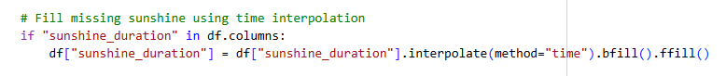Figure 4. Linear Interpolation code snippet.

Table 1. Open-Meteo Dataset.
date | temperature_2m_min | temperature_2m_max | rain_sum | wind_speed_10m_mean | relative_humidity_2m_mean | dew_point_2m_mean | sunshine_duration
2013-12-31 | 24.729500 | 27.479500 | 0.400000 | 20.971268 | 86.795143 | 23.458670 | 24058.076172
2014-01-01 | 24.629501 | 27.329498 | 7.399999 | 21.947840 | 86.367065 | 23.292000 | 33795.843750
2014-01-02 | 24.629501 | 28.879501 | 1.200000 | 17.666321 | 85.203285 | 23.352415 | 31352.314453
2014-01-03 | 24.629501 | 29.179501 | 0.100000 | 16.192158 | 83.461899 | 23.150335 | 37310.156250
2014-01-04 | 24.379501 | 27.529499 | 0.900000 | 20.674368 | 86.114296 | 23.141998 | 36720.382812

Time-Series Segmentation
The data were transformed into fixed-length sequences to capture temporal dependencies. Each sequence consisted of a set of consecutive daily observations, including humidity, temperature, wind speed, sunshine, dew point, and rainfall as input, and the corresponding target output predicted the following day’s values of each parameter. This approach ensured that the LSTM model could effectively learn the temporal patterns and dependencies within the dataset.

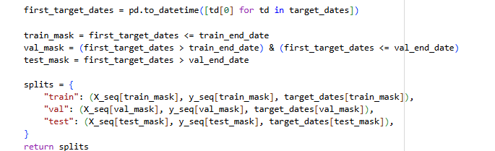
Figure 5. Time-Series Segmentation code snippet.
Normalization
Given that Long Short-Term Memory (LSTM) models are sensitive to the scale of input data, the researchers applied Min-Max normalization to rescale continuous parameters into a standardized range of 0 to 1. This normalization step enabled the model to learn more efficiently and ensured stable performance during training. The code for Linear Normalization can be found in Figure 6. Specifically for this step, only 80% of data ,which is reserved for training, is the only portion of the data that is normalized, the remaining 20% which is split into testing and validation remains untouched.
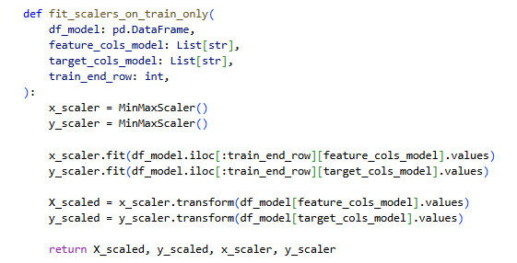

Figure 6. Linear Normalization code snippet.

Table 2. Normalized Weather Dataset.
date | temperature_2m_min | temperature_2m_max | rain_sum | wind_speed_10m_mean | relative_humidity_2m_mean | dew_point_2m_mean | sunshine_duration
2013-12-31 | 0.651286 | 0.307339 | 0.065351 | 0.658468 | 0.770363 | 0.747054 | 0.559089
2014-01-01 | 0.638832 | 0.293578 | 0.413357 | 0.692252 | 0.758213 | 0.727211 | 0.797447
2014-01-02 | 0.638832 | 0.435780 | 0.153138 | 0.544136 | 0.725184 | 0.734404 | 0.734618
2014-01-03 | 0.638832 | 0.463303 | 0.018512 | 0.493139 | 0.675761 | 0.710346 | 0.916642
2014-01-04 | 0.607697 | 0.311926 | 0.124664 | 0.648197 | 0.751039 | 0.709353 | 0.881606

D. Model Architecture
The researchers adopted a Long Short-Term Memory (LSTM) network as the core model architecture for weather prediction. LSTM was designed to capture long-term dependencies in sequential data, making it particularly effective for modeling temporal meteorological patterns. The model was trained on multivariate time series data, incorporating key variables such as humidity, temperature, wind speed, sunshine, dew point, and rainfall, as these are the most important elements of the country's weather and climate. The LSTM model’s inherent flexibility in handling missing data and its ability to model complex, multi-parameter relationships further justified its selection for this study.
Found in Figure 7 is the detailed model architecture, which includes the following components:
Input Layer: Accepts sequences of normalized temperature, rainfall amount, humidity, wind speed, dew point, and sunshine readings. The input shape is determined by the number of time steps and the number of features.
LSTM Layer 1: The first LSTM layer will process the sequential input data, learning temporal dependencies and short-term patterns in the time series.
LSTM Layer 2: A second LSTM layer will further refine the learned features from the first layer, capturing more complex dependencies and ensuring a robust representation of the time-series data.
Dense Layer 1: A fully connected layer introduces additional complexity and non-linearity to the model, transforming the features learned by the LSTM layers.
Dense Layer 2: Another fully connected layer further refines and processes the learned features.
Output Layer: The output layer will generate predictions for the forecasted weather parameters.
The model will utilize the Adam optimizer for efficient gradient descent, with mean squared error (MSE) employed as the loss function to evaluate the difference between predicted and actual temperatures. The Python implementation of this stacked LSTM architecture is provided in the code snippets shown in Figure 8 and Figure 8a.

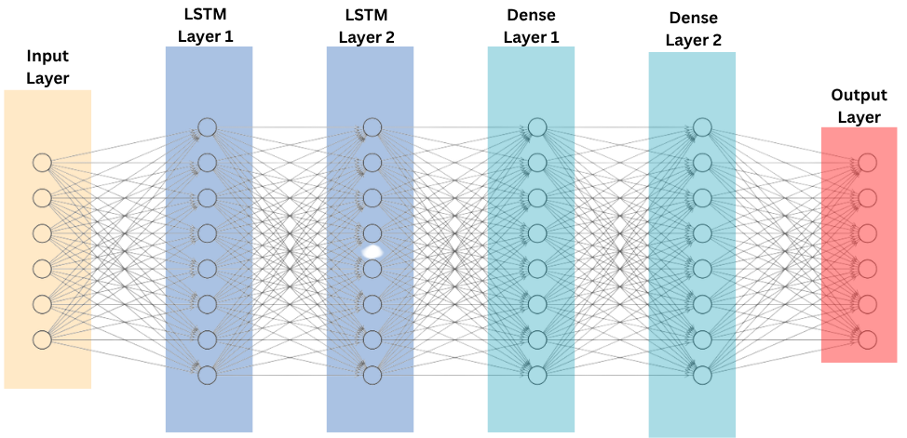

Figure 7. LSTM Model Architecture for Weather Prediction.
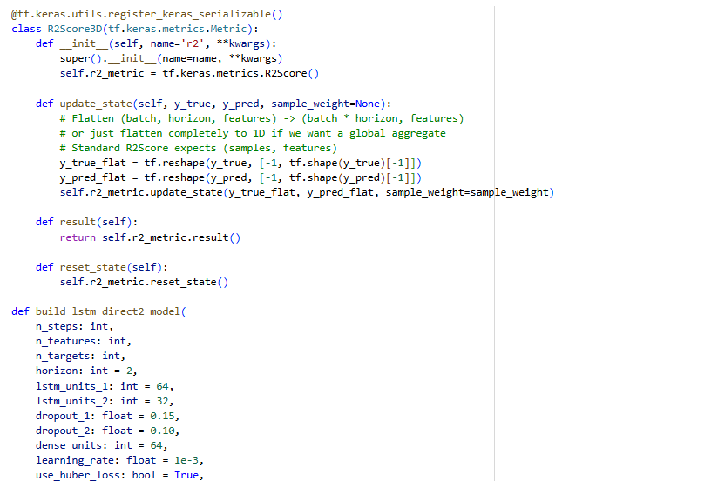

Figure 8a. Model Creation Snippet.

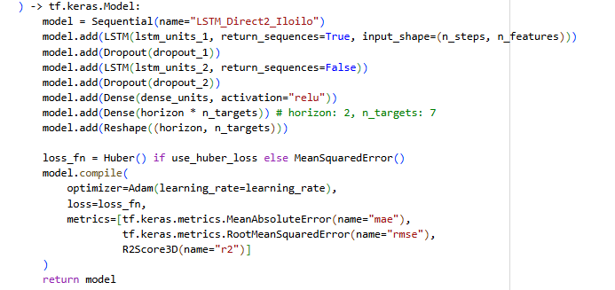
Figure 8b. Continuation of Model Creation Snippet.

E. Training and Validation
Data Splitting
The dataset was partitioned into three subsets: 80% for training, 10% for validation, and 10% for testing. The training set was used to teach the model patterns from historical data, while the validation set was utilized during training for hyperparameter tuning and iterative evaluation. The test set, kept entirely unseen during training and validation, was reserved exclusively for assessing the model’s final forecasting accuracy. This ensured that the model’s evaluation was performed on data that mimicked real-world forecasting scenarios and avoided data leakage. The training configuration, including the Adam optimizer and early stopping, is illustrated in the code snippets found in Figure 9 and Figure 9a.
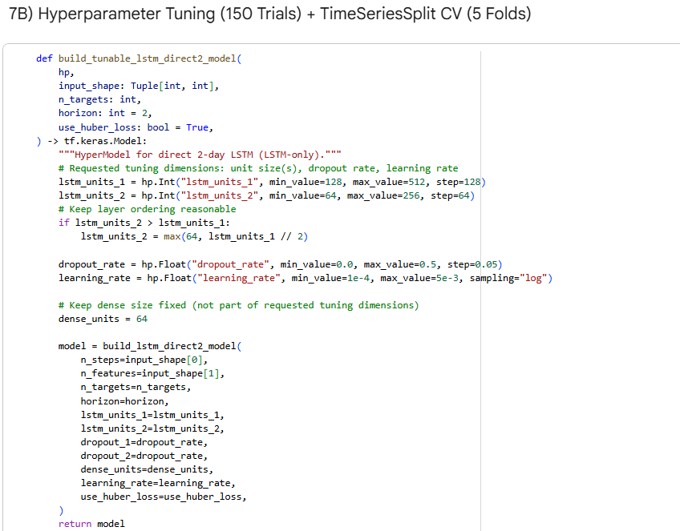

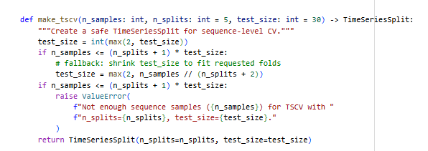
Figure 9a. Model Training code snippet.

Figure 9b. Continuation of Model Training code snippet.

Cross Validation
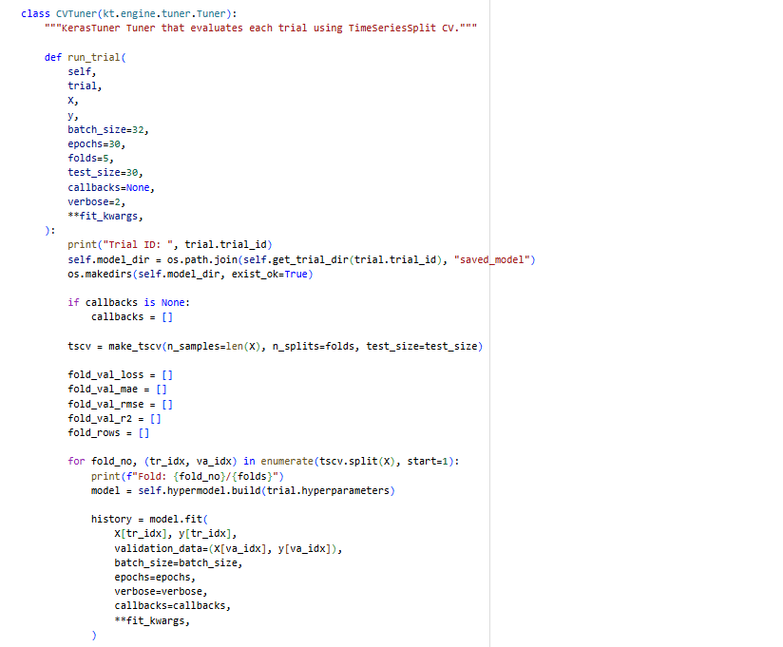
Time series cross-validation, specifically the walk-forward validation approach, was employed on the training set to validate the generalization capabilities of the LSTM model. This process involved iteratively training the model on an expanding window of past data and validating it on the subsequent data points. By preserving the temporal order of the dataset, walk-forward validation ensured that the model was evaluated on data it had not seen before, replicating real-world forecasting scenarios. This method helped identify potential overfitting or underfitting issues and enhanced the model's performance on unseen data. The implementation details of the walk-forward validation using the Cross Validation Class can be seen in the code snippets presented in Figure 10, Figure 10a, and Figure 10b.

Figure 10a. Cross Validation Class code snippet.

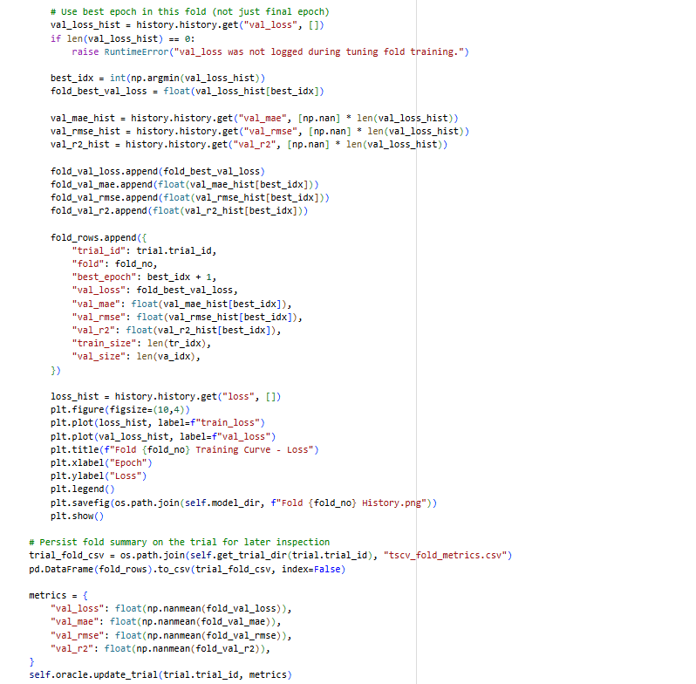
Figure 10b. Continuation Cross Validation Class code snippet.

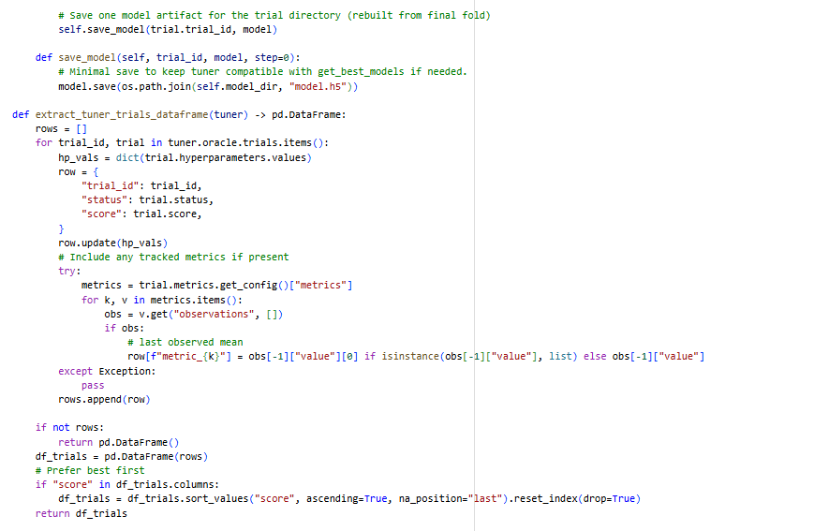
Figure 10c. Continuation Cross Validation Class code snippet.
Hyperparameter Optimization
To optimize the LSTM model's performance, several hyperparameters were adjusted, including the number of units in each LSTM layer, learning rate, dropout rate, and the regularization penalties. Hyperparameter tuning was performed using Bayesian Optimization, which efficiently explored the hyperparameter search space by constructing a probabilistic model of the objective function and selecting subsequent configurations based on prior evaluations. This approach enabled faster convergence toward optimal hyperparameter settings compared to conventional grid or random search methods.
The Adam optimizer was employed as the optimization algorithm. The LSTM layers used the ReLU (Rectified Linear Unit) activation function to address vanishing gradient issues and improve convergence. During training, the training loss (loss) was monitored to evaluate how well the model learned from the training data, while the validation loss (val_loss) provided insights into the model's performance on unseen validation data. Early stopping was also implemented, using val_loss as the metric to terminate training if no improvement was observed over a set number of iterations, ensuring optimal performance while preventing overfitting.

F. Evaluation Metrics
To evaluate the performance of the models in predicting weather variables for Iloilo, three evaluation metrics were used:
The coefficient of determination (R²), shown in Equation 2, assessed the goodness of fit and the ability of the model to explain the variance in the observed weather data.
The Mean Absolute Error (MAE), defined in Equation 3, evaluated the average magnitude of errors in the predictions, providing a straightforward measure of prediction reliability.
The Root Mean Squared Error (RMSE), expressed in Equation 4, provided a measure sensitive to larger errors, emphasizing the reliability of predictions.

G. Tools and Environment
The researchers utilized a combination of software tools and cloud-based platforms to train, implement, and manage the weather forecasting model. The primary programming language employed in this study was Python, chosen for its readability, extensive library support, and widespread use in machine learning and scientific computing. Python has become a standard tool for research involving data analysis and artificial intelligence due to its ease of use and strong community support.

To build and train the deep learning models, the researchers used the TensorFlow framework, along with its high-level API, Keras, which simplified the construction of complex neural network architectures. These frameworks provided modular, scalable, and efficient tools for developing and fine-tuning deep learning models. In addition, Pandas was employed for data manipulation and preprocessing tasks, particularly for handling time series data and preparing the input features required for model training.
All computational work was conducted on Google Colab, a cloud-based Jupyter notebook environment that offered free access to GPUs and TPUs, facilitating faster training of deep learning models without requiring local hardware resources. This platform also enabled easy sharing and collaboration among researchers.

Upon completion of the model development, the project and its associated files were version-controlled and made accessible via GitHub, an online repository hosting service that supported reproducibility and transparency in scientific research. Furthermore, the Flask web application developed for model deployment was hosted on free hosting platforms such as Render, allowing real-time access to the weather prediction system through a web interface without incurring additional costs.

Chapter 4
RESULTS AND DISCUSSION
This chapter presents the findings of the study based on the stated objectives. It discusses the dataset collection and preprocessing process, model training and evaluation, and the overall performance of the proposed Long Short-Term Memory (LSTM) model in forecasting localized weather conditions in Iloilo City. The results are based on the experimental implementation conducted in Google Colab using Python, TensorFlow, and Keras.

4.1 Collection and Preprocessing of Weather Data
To achieve the first objective, the researchers collected a 10-year dataset (January 2014–December 2024) from the Open-Meteo API, consisting of seven primary meteorological parameters: minimum temperature (°C), maximum temperature (°C), relative humidity (%), wind speed (km/h), sunshine duration (s), dew point (°C), and rainfall amount (mm).
The raw dataset contained occasional missing values due to sensor and recording gaps, which were handled using linear interpolation to maintain temporal continuity. (refer to Figure 4 in Chapter 3 for the code snippet).
Subsequently, Min–Max normalization was applied to scale all variables within the range 0–1, ensuring that the model trained uniformly across features with different measurement units. The normalization and time-series segmentation procedures are detailed in the code snippets shown in Figure 5 and Figure 6 (Chapter 3). The dataset was first ordered by date. From this, 80% was set aside for training. A validation set equal to 20% of the training portion was taken from within the training data for model tuning. A separate 20% of the original dataset was reserved for testing. This approach preserves the temporal order of data, which is essential for time-series forecasting, while ensuring that the test set remains entirely unseen during model development for an unbiased evaluation of forecasting accuracy.
To implement the first objective in a practical setting, the trained LSTM model was deployed through a web‑based forecasting interface that allows users to explore the processed meteorological dataset.
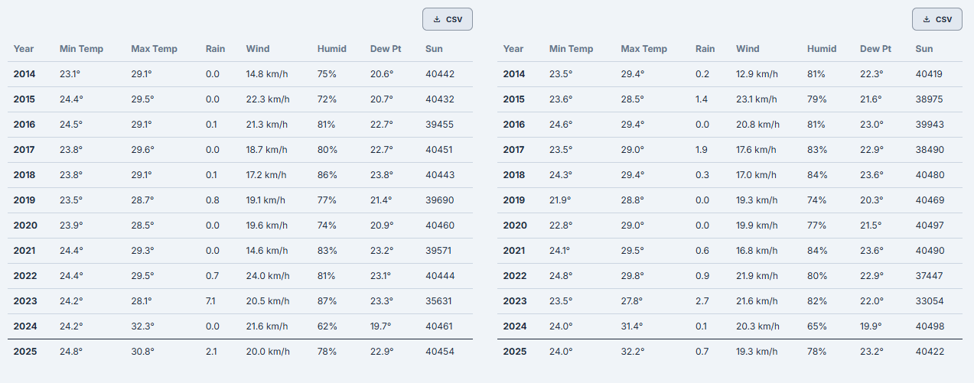

Figure 11. Historical Weather Data Visualization Table
Figure 11 presents the historical weather data table generated for the selected location and date range, listing daily values for minimum and maximum temperature, rainfall, wind speed, relative humidity, dew point, and sunshine duration. This tabular view provides users with a clear summary of the multi‑parameter dataset used to train the LSTM model and supports quick inspection of recent weather conditions before viewing the forecasts.

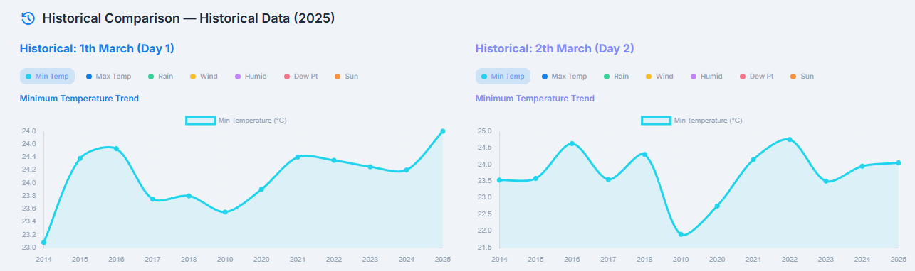

Figure 12. Historical Weather Data Visualization Chart
Figure 12 displays the charting component of the interface, which plots selected variables, such as minimum temperature, over the chosen period to highlight short‑term trends. Users can switch between parameters (for example, temperature, rainfall, wind speed, humidity, dew point, and sunshine duration), allowing them to observe temporal patterns visually and relate these patterns to the LSTM model’s predictions shown in later figures.

4.2 Design of the LSTM Model
A Long Short-Term Memory (LSTM) network was implemented using the Keras Sequential API. The model was designed to capture both short- and long-term dependencies among weather parameters. The full implementation of this architecture can be seen in the code snippets of Figure 8 and Figure 8a (Chapter 3).

Table 3. Final Model Architecture
Layer Type | Description
LSTM Layer 1 | Consists of 384 units and accepts six normalized weather parameters as input features for each time step.
LSTM Layer 2 | 128 units in ReLU activation function to learn short-term dependencies.
Dropout Layer | Dropout rate of 0.45 to prevent overfitting.
Dense Layer 1 | 128 neurons with ReLU activation for feature refinement.
Dense Layer 2 | 64 neurons with ReLU activation for feature refinement.
Output Layer | Linear activation that produces forecasted values for each parameter.

The first LSTM layer, with 384 units, receives six normalized weather features per time step, while the second LSTM layer with 128 units and ReLU activation focuses on capturing short-term temporal patterns in the data, consistent with the findings of Hewamalage et al. [65] and Lim and Zohren [66], who demonstrated that stacked LSTM architectures effectively capture temporal dependencies in nonlinear time-series data. A dropout rate of 0.45 is applied to reduce overfitting, followed by two dense layers, 64 and 14 neurons with ReLU activation, for feature refinement before the linear output layer generates forecasts for all target variables. The model was trained for 100 epochs with a batch size of 32 using the Adam optimizer and Mean Squared Error (MSE) as the loss function, with early stopping triggered after five epochs without validation loss improvement to preserve generalization performance, an approach validated by Taslim and Murwantara [13] in their comparative study of LSTM-based weather forecasting models.

4.3 Training the LSTM Model on Meteorological Features
The procedures for model fitting, including the use of the Adam optimizer, Mean Squared Error loss, and early stopping, as well as the implementation of walk-forward cross-validation, are detailed in the code snippets in Figure 9, Figure 9a, Figure 10, Figure 10a, and Figure 10b (Chapter 3).
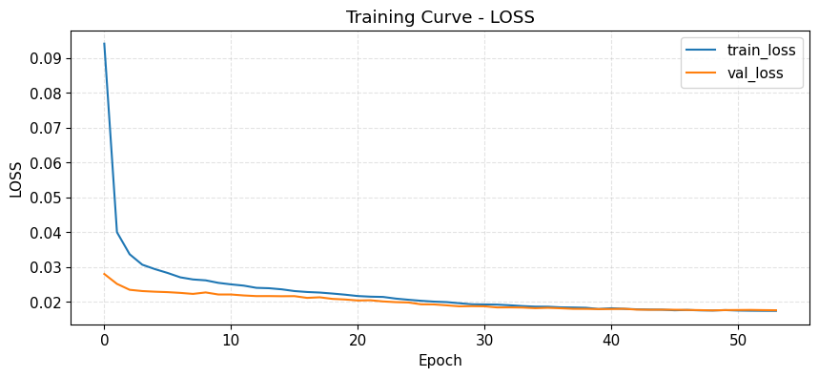

Figure 13. Training vs. Validation Loss Curve
Figure 13 illustrates the training progression of the LSTM model through its loss curves. Both training and validation losses decrease rapidly during the early epochs, indicating that the model quickly learns the underlying temporal patterns in the weather dataset. The curves then decline more gradually and begin to stabilize at approximately epoch 25, where only minimal changes are observed and the gap between the two curves remains small. This pattern indicates stable convergence and suggests that the model captures temporal dependencies without significant overfitting. The absence of an increasing trend in validation loss further implies good generalization on unseen weather data, supporting the suitability of the model for localized forecasting in Iloilo. This behavior is consistent with the observations of Hewamalage et al. [65] and Lim and Zohren [66] regarding effective LSTM training for time-series forecasting.

4.4 Evaluation of the LSTM Model’s Performance
To address the fourth objective, the LSTM model’s forecasting accuracy was evaluated using Root Mean Squared Error (RMSE), Mean Absolute Error (MAE), and R-squared (R²). These metrics quantify prediction precision, average deviation, and model fit, respectively.

Table 4a. Performance of the LSTM Model on Test Data (Horizon One)
Feature | MAE | RMSE | R²
Min Temperature | 0.066842 | 0.084252 | 0.571257
Max Temperature | 0.088507 | 0.104992 | 0.735668
Rain Sum | 0.106407 | 0.138292 | 0.538420
Mean Wind Speed | 0.082802 | 0.109347 | 0.772365
Mean Relative Humidity | 0.079829 | 0.105108 | 0.853878
Mean Dew Point | 0.050618 | 0.073098 | 0.806746
Sunshine Duration | 0.102173 | 0.165409 | 0.356124
Average | 0.082454 | 0.11150 | 0.662065

Table 4b. Performance of the LSTM Model on Test Data (Horizon Two)
Feature | MAE | RMSE | R²
Min Temperature | 0.071676 | 0.090777 | 0.501987
Max Temperature | 0.094402 | 0.113017 | 0.693748
Rain Sum | 0.115781 | 0.148475 | 0.467545
Mean Wind Speed | 0.116108 | 0.153326 | 0.552628
Mean Relative Humidity | 0.092849 | 0.120736 | 0.807424
Mean Dew Point | 0.062204 | 0.090356 | 0.704699
Sunshine Duration | 0.118831 | 0.181555 | 0.224018
Average | 0.095979 | 0.12832 | 0.564578

Table 4c. Performance of the LSTM Model on Test Data (Combined Test Results)
Result | MAE | RMSE | R²
Horizon 1 | 0.082454 | 0.111500 | 0.662065
Horizon 2 | 0.095979 | 0.128320 | 0.564578
Average | 0.089216 | 0.11991 | 0.613322

Table 4a, 4b, and 4c presents the performance of the LSTM model on the test dataset, evaluated using RMSE, MAE, and R² metrics for each meteorological parameter, as specified in the fourth objective. The evaluation results demonstrate the LSTM model effectively learned temporal dependencies among Iloilo's weather variables, particularly for parameters with smoother temporal behavior. These findings support earlier work showing LSTM networks are well-suited for modeling nonlinear, time-dependent meteorological patterns and can outperform traditional approaches in weather prediction tasks, as reported by Xie et al. [10], Hewamalage et al. [65], and Teixeira et al. [83].
Temperature forecasts obtained moderate R² scores, indicating the model reliably captured seasonal trends but showed reduced accuracy during abrupt temperature shifts associated with local microclimatic effects. Similar behavior of deep recurrent models has been documented in temperature-focused forecasting studies by Sarwade et al. [82] and Cruz et al. [76], who noted models reproduce overall temperature cycles but struggle with daily extremes.
Rainfall and sunshine duration produced the lowest R² values, highlighting LSTM's limitations in representing highly stochastic, event-driven variables whose extremes depend on localized convective activity and cloud cover. This difficulty aligns with observations by Teixeira et al. [83] and Tarawneh et al. [89], who noted noisy, rapidly changing atmospheric processes reduce accuracy of data-driven models even when general patterns are captured. Additionally, studies by Shekana et al. [58] and Lagrazon et al. [77] reported similar challenges in rainfall prediction using machine learning models in tropical climates.
The overall R² value of 0.551207, together with relatively low global RMSE and MAE, indicates moderate to strong predictive capacity for multivariate localized weather forecasting. This confirms the advantage of LSTM over traditional linear models such as ARIMA in capturing complex temporal dependencies in meteorological time series. This conclusion aligns with comparative studies where LSTM achieved better performance than ARIMA in volatile environments, as shown by Taslim and Murwantara [13] and Kolambe and Arora [62].
The interpretation of this R² value should be contextualized within established statistical standards and the inherent variability of weather data. According to Hair et al. [90], R² values around 0.50 are considered indicative of moderate explanatory power, particularly in complex and noisy datasets where perfect prediction is difficult to achieve. Similarly, Cohen [91] classifies R² values as low as 0.26 as representing a large effect size, suggesting that moderate R² values can still reflect meaningful predictive relationships. In meteorological forecasting, where atmospheric processes are nonlinear and highly stochastic, moderate R² values are commonly observed and accepted. This is supported by Sarwade et al. [82], who reported a total R² value of 0.24496 in weather prediction while still achieving over 70% prediction accuracy, demonstrating that lower R² values do not necessarily indicate poor model performance. Furthermore, studies such as Tarawneh et al. [89] and Lagrazon et al. [77] emphasize that even advanced machine learning models encounter difficulty in predicting highly variable weather parameters, often relying more on RMSE and MAE as indicators of practical forecasting performance. Therefore, the obtained R² value of 0.551207, can be considered a reliable and meaningful measure of model effectiveness within the context of localized weather forecasting.
Beyond model fit, the absolute error metrics provide a clearer picture of the model’s practical precision. The attained overall RMSE of 0.132405 and MAE of 0.099652 are particularly significant when considered on a normalized scale (0 to 1). An MAE of 0.071 indicates that, on average, the model’s predictions deviate by only 9.9% from the actual observed values. This low average error suggests high reliability for daily operational use. Furthermore, the RMSE value, which is slightly higher than the MAE, indicates a relative absence of large outliers or extreme forecasting failures, as RMSE is more sensitive to large errors [92]. The consistency between these two metrics suggests that the model’s optimization process successfully balanced general trends with localized fluctuations. As noted by Chai and Draxler [92], a small difference between RMSE and MAE implies that the error distributions are relatively uniform, confirming the stability of the LSTM architecture in handling the volatile atmospheric conditions of Iloilo.
These outcomes have practical implications for Iloilo, since improved short-term forecasts of humidity, temperature, and wind speed can support agricultural scheduling, event planning, and disaster risk preparedness. Even moderately accurate rainfall and sunshine predictions provide useful guidance for advisory purposes. Building on recent Philippine applications of machine learning in weather and climate, such as those by Cruz et al. [76], Namok and Luzano [78], and Ruaro and So [79], future work could integrate satellite-based rainfall products, additional atmospheric predictors, or hybrid machine-learning approaches to further enhance performance, particularly for precipitation-related variables.
Visualization of Results
The model’s predictive performance was visualized by plotting the actual vs. predicted values for each meteorological parameter.
Most weather features demonstrated closely aligned trends, with small deviations observable in high-variance variables like rainfall and sunshine duration.
These visual comparisons confirm that the LSTM model effectively captured temporal dependencies and localized weather fluctuations in Iloilo.

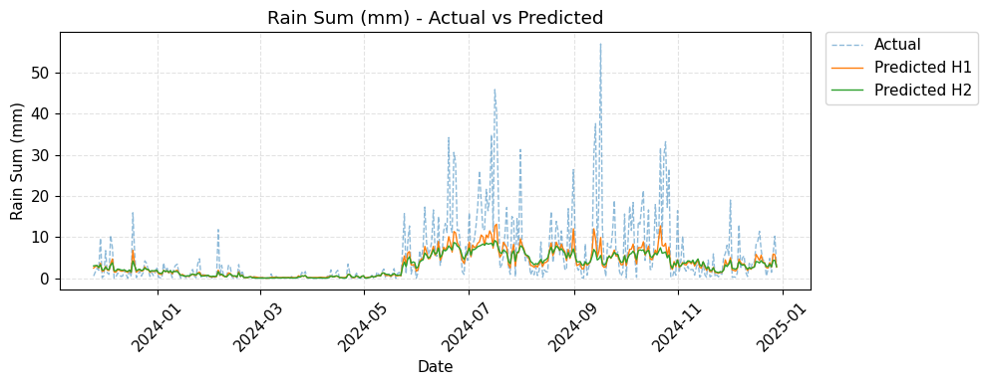
Figure 14a. Actual vs. Predicted Values for Rain Sum
Figure 14a shows that the predicted rainfall values follow the overall seasonal pattern of the actual rain sum series, capturing periods of relatively dry and wet conditions over time, but consistently underestimating sharp rainfall spikes and extreme events. This behavior is consistent with the low R² for Rain Sum in Table 4, indicating that sudden, high-intensity precipitation remains challenging for the LSTM model to learn accurately despite its ability to model general trends. This difficulty in predicting extreme rainfall events is a common challenge noted in Philippine-specific ML studies; Lagrazon et al. [77] and Namok and Luzano [78] also reported similar limitations in their rainfall prediction models for Cavite and Southern Philippines, respectively. In addition, Benoit et al. [93] emphasized that rainfall patterns on tropical islands are highly variable and often modeled probabilistically due to complex interactions between topography, atmospheric circulation, and sudden weather events, which further explains the model’s struggles with extreme precipitation.

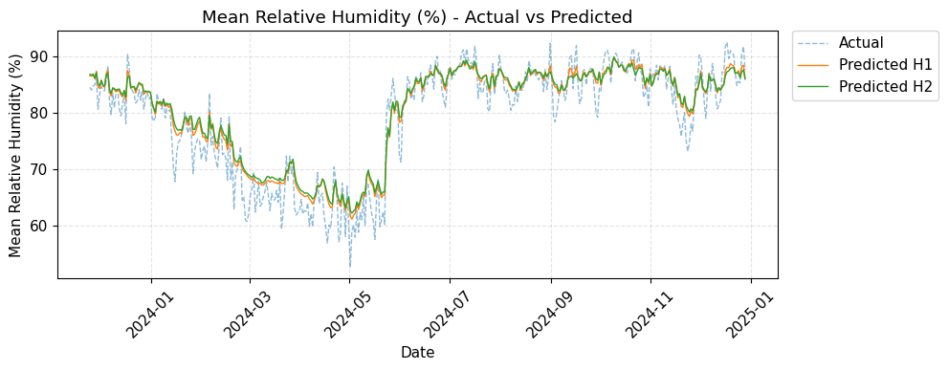
Figure 14b. Actual vs. Predicted Values for Mean Relative Humidity
Figure 14b shows that the predicted mean relative humidity closely tracks the actual series across the entire test period, with the red prediction line overlapping most of the blue actual values, including the pronounced drop in humidity around 2024. This close alignment is consistent with the high R² value (0.836125) and relatively low RMSE and MAE for Mean Relative Humidity reported in Table 4, indicating that the LSTM model effectively captures the temporal dynamics of humidity in Iloilo’s tropical climate. This close alignment is consistent with the high R² value (0.778525), indicating that the LSTM model effectively captures the temporal dynamics of humidity [This strong performance for a smoothly varying parameter aligns with findings that LSTMs are effective at modeling such temporal dependencies, as highlighted in the work of Xie et al. [10] on multivariate LSTM models.

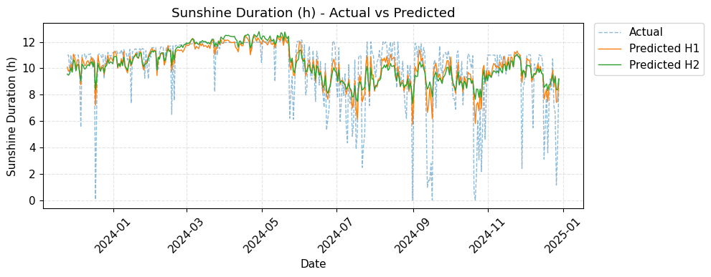
Figure 14c. Actual vs. Predicted Values for Sunshine Duration
Figure 14c shows that the predicted sunshine duration generally follows the central tendency of the actual series, but the model fails to capture many of the sharp dips to very low or zero sunshine values, resulting in noticeable discrepancies during cloudy or stormy periods. This behavior aligns with the relatively low R² (0.487596) and the higher RMSE and MAE values for sunshine duration in Table 4, indicating that while the LSTM model can approximate typical daily sunshine levels, it struggles to detect sudden reductions in solar exposure.
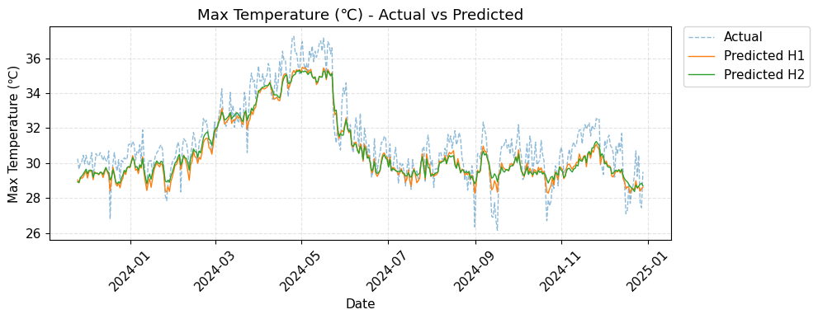
These abrupt declines typically occur when cloud cover forms or changes rapidly, blocking sunlight in short, irregular intervals. Because these events are highly dynamic, short-lived, and strongly weather-driven, they introduce complex variability that is difficult for data-driven time-series models to learn. This limitation is consistent with Teixeira et al.[83], who described solar-radiation–related variables as highly stochastic and event-driven, making extreme decreases challenging to forecast accurately. Similarly, Tuononen et al. [94] noted that rapid cloud evolution creates sharp and unpredictable fluctuations in surface solar irradiance, leading to large forecast errors during cloudy or stormy periods. Since sunshine duration is directly dependent on these irradiance fluctuations, the LSTM’s difficulty in predicting sharp dips reflects the inherent atmospheric variability affecting sunlight availability.

Figure 14d. Actual vs. Predicted Values for Max Temperature
Figure 14d shows that the predicted maximum temperature follows the overall seasonal pattern of the actual series, including the pronounced warming peak around mid‑2024, but smooths out short‑term fluctuations, leading to underestimation of some extreme hot days and overestimation of some cooler days. This behavior is consistent with the moderate R² and error values for maximum temperature in Table 4, suggesting that while the LSTM model captures large‑scale trends and seasonal cycles, it has limited sensitivity to abrupt local variability typical of tropical climates such as Iloilo, where daily temperatures can change rapidly due to local convection, monsoon flows, and synoptic disturbances. Similar patterns have been reported in previous temperature‑focused studies: Cruz et al. [76] showed that machine‑learning models can effectively reproduce seasonal temperature patterns but still miss some extreme maxima; Cinco et al. [60] and Villafuerte et al. [61] documented increasing temperature trends and more intense hot events in the Philippines, underscoring the difficulty of modeling daily extremes in a warming tropical climate; and Sarwade et al. [82] observed that data‑driven models often achieve better accuracy for mean temperature behavior than for day‑to‑day extreme values.

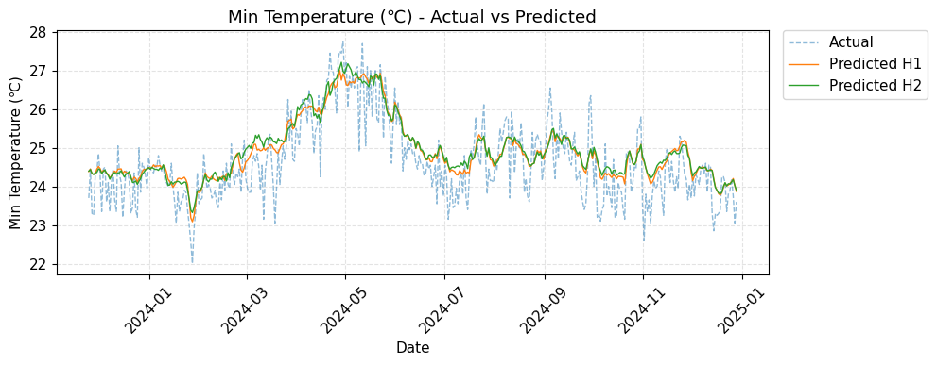
Figure 14e. Actual vs. Predicted Values for Min Temperature
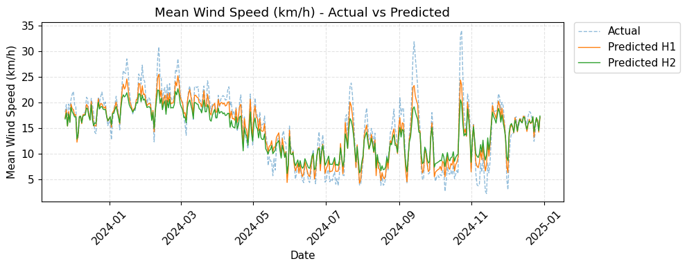
Figure 14e shows that the predicted minimum temperature closely follows the overall pattern of the actual series, with the LSTM model successfully capturing seasonal cooling and warming cycles and maintaining relatively small deviations during most nights. This agreement is consistent with the moderate R² and low error values for minimum temperature in Table 4, indicating that the model can reliably reproduce night‑time temperature behavior even though some sharper cool anomalies remain slightly underestimated. Similar behavior has been observed in deep learning–based time‑series forecasting studies, where LSTM and related architectures accurately model overall trends but tend to smooth high‑frequency variations, as discussed by Hewamalage et al. [65], Lim and Zohren [66], and Kolambe and Arora [62].

Figure 14f. Actual vs. Predicted Values for Mean Wind Speed
Figure 14f shows that the predicted mean wind speed captures the broad seasonal cycles of wind intensity, with higher values during monsoon periods and lower values in calmer seasons, but it smooths many of the sharp gusts and localized peaks present in the actual series. This pattern is consistent with the relatively high R² and moderate error metrics for Mean Wind Speed in Table 4, indicating that the LSTM model effectively learns the underlying temporal structure of wind variability while still underrepresenting extreme short‑duration wind events, a challenge also observed for key meteorological parameters such as wind speed in the work of Shekana et al. [58] and in LSTM‑based weather studies by Teixeira et al. [83] and Salman et al. [84].

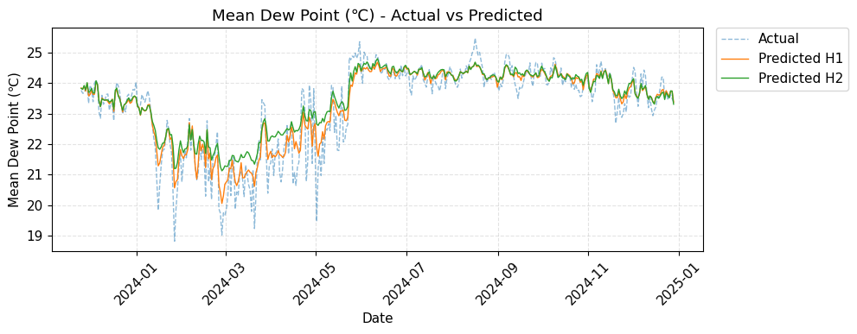
Figure 14g. Actual vs. Predicted Values for Mean Dew Point
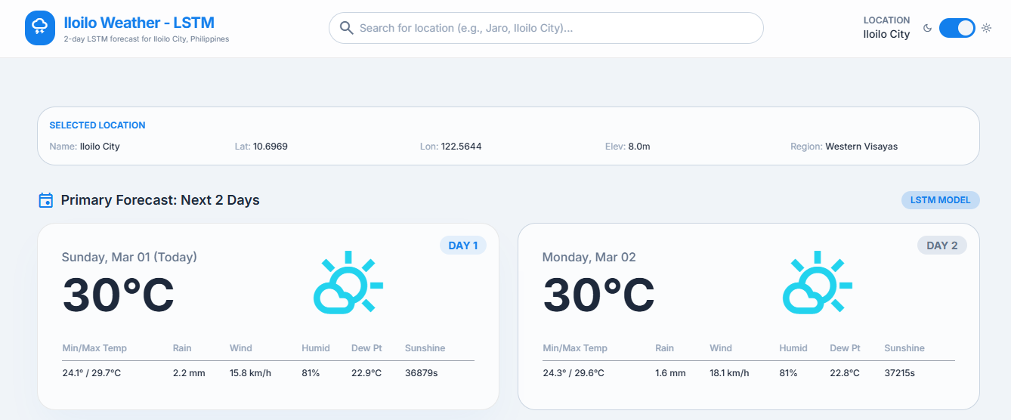

Figure 15. Predicted Weather Forecast on the Web-based Interface.
To implement the trained LSTM model in a practical setting, the web‑based interface allows users to generate short‑term forecasts for a selected location. Figure 15 shows the Forecast section of the interface, where the system displays the n‑day predictions produced by the LSTM model, including minimum and maximum temperature, rainfall, wind speed, relative humidity, dew point, and sunshine duration for each forecast day.
The evaluation results demonstrate that the LSTM model effectively learned the temporal dependencies among Iloilo’s weather variables, particularly for parameters with smoother temporal behavior such as wind speed, relative humidity, and dew point, which achieved high R² values and low error metrics in the test set. These findings support earlier work showing that LSTM networks are well suited for modeling nonlinear, time‑dependent meteorological patterns and can outperform traditional approaches in weather prediction tasks, as reported by Xie et al. [10], Hewamalage et al. [65], and Teixeira et al. [83].​
Temperature forecasts for both minimum and maximum values obtained moderate R² scores, indicating that the model reliably captured seasonal trends but showed reduced accuracy during abrupt temperature shifts associated with local microclimatic effects. Similar behavior of deep recurrent models, which reproduce overall temperature cycles but struggle with daily extremes, has been documented in temperature‑focused forecasting and climate studies by Sarwade et al. [82], Cruz et al. [76], Cinco et al. [60], and Villafuerte et al. [61].​
Rainfall and sunshine duration produced the lowest R² values, highlighting the LSTM model’s limitations in representing highly stochastic and event‑driven variables whose extremes depend on localized convective activity and cloud cover. This difficulty in forecasting irregular precipitation and solar‑radiation‑related variables is consistent with the observations of Teixeira et al. [83], Tarawneh et al. [89], Shekana et al. [58] , and Lagrazon et al. [77], who noted that noisy, rapidly changing atmospheric processes reduce the accuracy of data‑driven models even when general wet–dry or bright–cloudy patterns are captured.​
The overall R² value, together with relatively low global RMSE and MAE, indicates a moderate to strong predictive capacity for multivariate localized weather forecasting and confirms the advantage of LSTM over traditional linear models such as ARIMA in capturing complex temporal dependencies in meteorological time series. This conclusion aligns with comparative studies where LSTM and related deep learning models achieved better performance than ARIMA and other classical methods in volatile environments, as shown by Taslim and Murwantara [13], Kolambe and Arora [62], Lim and Zohren [66], and Saadeddin [72]. ​
These outcomes have practical implications for Iloilo, since improved short‑term forecasts of humidity, temperature, and wind speed can support agricultural scheduling, event planning, and disaster risk preparedness, while even moderately accurate rainfall and sunshine predictions provide useful guidance for advisory purposes. Building on recent Philippine applications of machine learning in weather and climate, such as those by Cruz et al. [76], Namok and Luzano [78], and Ruaro and So [79], future work could integrate satellite‑based rainfall products, additional atmospheric predictors, or hybrid machine‑learning and numerical‑model approaches to further enhance performance, particularly for precipitation‑related variables.​

Chapter 5
SUMMARY, CONCLUSION, AND RECOMMENDATION

SUMMARY
This study aimed to develop a Long Short-Term Memory (LSTM)–based localized weather forecasting model for Iloilo that can predict next‑day values of key meteorological parameters, namely minimum and maximum temperature, relative humidity, wind speed, sunshine duration, dew point, and rainfall amount. It specifically sought to (1) collect and preprocess a 10‑year historical weather dataset for Iloilo, (2) design an LSTM architecture capable of learning temporal dependencies in these variables, (3) train the model using the selected meteorological parameters as both inputs and prediction targets, and (4) evaluate its performance using Root Mean Squared Error (RMSE), Mean Absolute Error (MAE), and R‑squared (R²).
To achieve these objectives, ten years of hourly weather data (January 2014–December 2024) were gathered from the Open‑Meteo API and processed through data cleaning, linear interpolation for missing values, and Min–Max normalization. The dataset was then segmented chronologically into training, validation, and test sets to preserve temporal order. An LSTM model was implemented in Python using TensorFlow and Keras, composed of stacked LSTM layers, dropout for regularization, dense layers for feature refinement, and a linear output layer that simultaneously produced forecasts for all target parameters. The model was trained using the Adam optimizer and Mean Squared Error loss, with early stopping based on validation loss to prevent overfitting.
The trained LSTM model was assessed on the test set using RMSE, MAE, and R² for each weather parameter, complemented by visual comparisons of actual versus predicted time‑series plots. The results showed strong predictive performance for parameters with smoother temporal behavior, particularly mean dew point, mean wind speed, and mean relative humidity, all of which achieved high R² and low error values. Minimum and maximum temperature obtained moderate R² scores, indicating that the model captured seasonal warming and cooling patterns but was less accurate during sudden temperature extremes. Rainfall and sunshine duration produced the lowest R² values, reflecting the difficulty of modeling highly variable and event‑driven elements such as convective rainfall and short‑lived cloud cover. Overall, the global R² and error metrics indicated a moderate to strong predictive capacity for multivariate localized weather forecasting in Iloilo.
In relation to the research problem, the findings demonstrate that an LSTM‑based approach can improve localized short‑term weather prediction for Iloilo, especially for parameters that vary smoothly over time, such as humidity, temperature, wind speed, and dew point. While accuracy for rainfall and sunshine duration remains limited, the model still captured general wet‑dry and bright‑cloudy patterns, offering useful guidance for short‑term planning. These outcomes suggest that LSTM models provide a sound basis for localized forecasting systems that may later include additional spatial and atmospheric information.

CONCLUSION
Based on the findings, the following conclusions were drawn:
- A ten‑year historical weather dataset for Iloilo City was successfully collected from the Open‑Meteo API, cleaned, interpolated for missing values, normalized, and chronologically partitioned into training, validation, and test sets, providing a reliable time‑series foundation for model development.
- A stacked LSTM architecture was designed and implemented, with appropriate layer sizes, activation functions, and regularization, allowing the model to learn both short‑ and long‑term temporal dependencies among the selected meteorological variables.
- The LSTM model was trained using minimum and maximum temperature, relative humidity, wind speed, sunshine duration, dew point, and rainfall amount as multivariate inputs and outputs, enabling it to generate next‑day forecasts at the same time for all target parameters.
- Evaluation using RMSE, MAE, and R² showed that the LSTM model achieved high predictive accuracy for dew point, relative humidity, and mean wind speed, and moderate accuracy for minimum and maximum temperature, which means it can represent smooth, trend‑based weather behavior in Iloilo with reasonable precision.
- The relatively low R² values for rainfall and sunshine duration confirm that the LSTM model, while suitable for smooth variables, is insufficient on its own for accurately forecasting highly random and event-driven conditions, necessitating the integration of richer, high-resolution data or hybrid modeling approaches in future work.
- Considering the overall R² and error metrics across all parameters, the LSTM model shows a moderate to strong level of performance for multivariate localized weather forecasting in Iloilo, confirming that LSTM neural networks are suitable tools for continuous operational forecasting in tropical urban settings.

RECOMMENDATION
In light of the conclusions, the following recommendations are proposed:
- Future studies may extend the dataset by including additional years of local observations and higher‑resolution data, including station‑level measurements where available, to further improve the stability of the model’s estimates.
- Additional atmospheric variables such as air pressure, cloud cover, and large‑scale climate indices may be added to the input features to increase prediction accuracy for highly variable parameters, particularly rainfall and sunshine duration.
- Hybrid approaches may be explored, such as combining LSTM outputs with Numerical Weather Prediction or other statistical models, to better capture extreme events and sudden weather changes.
- Model enhancements may be developed so that the system can better detect and react to rapid shifts in weather conditions, including the formation and passage of typhoons and other severe weather phenomena that affect Iloilo and nearby areas.
- Field validation and user‑acceptance testing may be carried out with stakeholders in agriculture, disaster risk reduction, and community planning to examine the practical usefulness, clarity, and timeliness of the forecasts.
- Future researchers may investigate adaptation strategies so that the trained LSTM framework can be reused or fine‑tuned for nearby provinces or other Philippine cities with similar climatic conditions.

References
[1] E. Cruz, R. Rojo, L. Bacalla, and A. Eusebio, "Spatiotemporal analysis of the urban cooling island (UCI) effect of water spaces in a highly urbanized city: A case study of Iloilo River and adjacent wetlands," ISPRS Archives, vol. XLII-4/W19, pp. 149–156, 2019. [Online]. Available: https://isprs-archives.copernicus.org/articles/XLII-4-W19/149/2019/isprs-archives-XLII-4-W19-149-2019.pdf

[2] S. Bito-onon, "Climate risk vulnerability assessment: Basis for decision making support for the agriculture sector in the province of Iloilo," International Journal of Innovation, Creativity and Change, vol. 13, no. 3, pp. 137–159, 2020. [Online]. Available: https://www.ijicc.net/images/vol_13/Iss_3/13335_Onon_2020_E_R.pdf

[3] R. Blaga, D. Mihăilă, and C. Miclaus, "Numerical Weather Prediction Model," ScienceDirect, 2019. [Online]. Available: https://www.sciencedirect.com/topics/engineering/numerical-weather-prediction-model

[4] NOAA, "Numerical weather prediction," n.d. [Online]. Available: https://www.ncei.noaa.gov/products/weather-climate-models/numerical-weather-prediction

[5] L. Zanchi, "Improving localized weather predictions for precision agriculture: A Time-Series Mixer approach for hazardous event detection," Computers and Electronics in Agriculture, vol. 215, 2025. [Online]. Available: https://www.sciencedirect.com/science/article/pii/S1364815225001938

[6] A. Hayes, "Autoregressive Integrated Moving Average (ARIMA) prediction model," Investopedia, 2024. [Online]. Available: https://www.investopedia.com/terms/a/autoregressive-integrated-moving-average-arima.asp

[7] Z. Saadeddin, "ARIMA for time series forecasting: A complete guide," DataCamp, 2025. [Online]. Available: https://www.datacamp.com/tutorial/arima

[8] A. Chaitanya, "Weather prediction using CNN and image processing," Medium, 2023. [Online]. Available: https://medium.com/@alladichaitanya08/wether-predection-using-cnn-and-image-processing-ca1ca5a16a6d

[9] V. Srivastava, "Weather prediction using LSTM neural networks," IEEE Xplore, 2022. [Online]. Available: https://ieeexplore.ieee.org/document/9824268

[10] J. Xie, W. Zhang, and T. Li, "Weather prediction based on multivariate LSTM neural network model," Typeset, 2024. [Online]. Available: https://typeset.io/papers/weather-prediction-based-on-multivariate-lstm-neural-network-ddkyxjy8nu

[11] S. Manandhar et al., "Systematic study of weather variables for rainfall detection," IEEE Trans. Geosci. Remote Sens., 2019. [Online]. Available: https://doi.org/10.1109/TGRS.2019.2905771

[12] R. Suhendra and A. Sutomo, "Relationship between temperature and humidity on rainfall: A study in Indonesia," EMACS J., 2019. [Online]. Available: https://journal.binus.ac.id/index.php/EMACS/article/view/11466

[13] A. Taslim and I. Murwantara, "Comparative analysis of ARIMA and LSTM for predicting fluctuating time series data," Typeset, 2024. [Online]. Available: https://typeset.io/papers/comparative-analysis-of-arima-and-lstm-for-predicting-5fns1ptfsj

[14] Y. Liu and J. Yu, "Predicting weather using LSTM neural networks," 2024. [Online]. Available: https://flybirdcl.github.io/

[15] Philippine Atmospheric, Geophysical and Astronomical Services Administration (PAGASA), "About Us", PAGASA, 2025. [Online]. Available: https://bagong.pagasa.dost.gov.ph/about-us.
[16] Open-Meteo, “Free Open-Source Weather API”, Open-Meteo, 2025. [Online]. Available: https://open-meteo.com/

[17] Philippine Atmospheric, Geophysical and Astronomical Services Administration (PAGASA), “How a Weather Forecast is Made”, PAGASA, 2025. [Online]. Available: https://www.pagasa.dost.gov.ph/learning-tools/how-weather-forecast-made#:~:text=Land%2Dbased%20weather%20stations%20around,anemometer%2C%20thermometer%2C%20psychrometer%20or%20hygrometer

[18] IBM, "What is overfitting?", IBM, 2021. [Online]. Available: https://www.ibm.com/think/topics/overfitting.

[19] J. Noble “Introducing ARIMA Models”, International Business Machines (IBM), 2025. [Online]. Available: https://www.ibm.com/think/topics/arima-model

[20] K. Tarek, "Future forecasting of time series using LSTM: A quick guide for business leaders," Medium, 2024. [Online]. Available: https://medium.com/@kareimtarek1972/future-forecasting-of-time-series-using-lstm-a-quick-guide-for-business-leaders-370661c574c9

[21] National Oceanic and Atmospheric Administration, "Glossary: Temperature," NOAA's National Weather Service, [Online]. Available: https://forecast.weather.gov/glossary.php?word=temperature

[22] NiuBoL, "Understanding Rainfall Measurement: Meaning, Methods, and Importance," [Online]. Available: https://www.niubol.com/Product-knowledge/Understanding-rainfall-measurement.html

[23] National Geographic Society, "Humidity," National Geographic Education, [Online]. Available: https://education.nationalgeographic.org/resource/humidity/

[24] Vaisala, "What is dew point and how to measure it?", Vaisala, [Online]. Available: https://www.vaisala.com/en/blog/2019-09/what-dew-point-and-how-measure-it.

[25] American Meteorological Society, "Sunshine", Glossary of Meteorology. [Online]. Available: https://glossary.ametsoc.org/wiki/Sunshine

[26] Encyclopedia of Atmospheric Sciences, "Wind speed", Encyclopedia of Atmospheric Sciences, 2003. [Online]. Available: https://www.sciencedirect.com/topics/agricultural-and-biological-sciences/wind-speed.

[27] ScienceDirect, "Root mean squared error," 2022. [Online]. Available: https://www.sciencedirect.com/topics/engineering/root-mean-square-error

[28] Y. Xia et al., "Mean absolute error", ScienceDirect, 2023. [Online]. Available: https://www.sciencedirect.com/topics/engineering/mean-absolute-error

[29] A. Muralidhar, "What is R-squared?", Built In, 2025. [Online]. Available: https://builtin.com/data-science/adjusted-r-squared

[30] InfluxData, "What is time series data?" 2025. [Online]. Available: https://www.influxdata.com/what-is-time-series-data/

[31] A. Jaiswal, "Normalization in machine learning", DataCamp, 2024. [Online]. Available: https://www.datacamp.com/tutorial/normalization-in-machine-learning

[32] Pandas, “DataFrame.interpolate. Pandas API reference”, 2026. [Online]. Available: https://pandas.pydata.org/docs/reference/api/pandas.DataFrame.interpolate.html

[33] Scikit-learn, “MinMaxScaler. Scikit-learn API reference”, 2025. [Online]. Available: https://scikit-learn.org/stable/modules/generated/sklearn.preprocessing.MinMaxScaler.html

[34] Keras, “Timeseries data loading. Keras API reference”, 2025. [Online]. Available: https://keras.io/api/data_loading/timeseries/

[35] Keras, “HyperParameters. Keras API reference”, 2025. [Online]. Available:
https://keras.io/keras_tuner/api/hyperparameters/

[36] TensorFlow, “Introduction to the Keras Tuner”, 2024. [Online]. Available: https://www.tensorflow.org/tutorials/keras/keras_tuner

[37] Keras, “Bayesian Optimization Tuner. KerasTuner API reference”, 2025. [Online]. Available: https://keras.io/keras_tuner/api/tuners/bayesian/

[38] Kingma, D. P., & Ba, J. “Adam: A method for stochastic optimization”, In International Conference on Learning Representations (ICLR), 2015. [Online]. Available: https://arxiv.org/abs/1412.6980

[39] Keras, “Adam optimizer. Keras API reference”, 2025. [Online]. Available: https://keras.io/api/optimizers/adam/

[40] Srivastava, N., Hinton, G., Krizhevsky, A., Sutskever, I., & Salakhutdinov, R. “Dropout: A simple way to prevent neural networks from overfitting”, Journal of Machine Learning Research, 2014. [Online]. Available: https://jmlr.org/papers/v15/srivastava14a.html

[41] Keras, “Dense layer. Keras API reference”, 2025. [Online]. Available: https://keras.io/api/layers/core_layers/dense/

[42] Keras, “ReLU layer. Keras API reference”, 2025. [Online]. Available: https://keras.io/api/layers/activation_layers/relu/

[43] Keras, “Losses. Keras API reference”, 2025. [Online]. Available: https://keras.io/api/losses/

[44] TensorFlow, “tf.keras.losses.MeanSquaredError. TensorFlow API reference”, 2024. [Online]. Available: https://www.tensorflow.org/api_docs/python/tf/keras/losses/MeanSquaredError

[45] Keras, “EarlyStopping. Keras API reference”, 2025. [Online]. Available: https://keras.io/api/callbacks/early_stopping/

[46] Keras., “Training and evaluation with the built-in methods (Model.fit)”, 2025. [Online]. Available: https://keras.io/guides/training_with_built_in_methods/

[47] Scikit-learn, “train_test_split. Scikit-learn API reference”, 2025. [Online]. Available: https://scikit-learn.org/stable/modules/generated/sklearn.model_selection.train_test_split.html

[48] Scikit-learn, “Cross-validation: Evaluating estimator performance. scikit-learn User Guide”, 2025. [Online]. Available: https://scikit-learn.org/stable/modules/cross_validation.html

[49] Scikit-learn, “TimeSeriesSplit.scikit-learn API reference”, 2025. [Online]. Available: https://scikit-learn.org/stable/modules/generated/sklearn.model_selection.TimeSeriesSplit.html

[50] Scikit-learn, “Common pitfalls and recommended practices. scikit-learn User Guide”, 2025. [Online]. Available: https://scikit-learn.org/stable/common_pitfalls.html

[51] Keras, “Layer weight regularizers. Keras API reference”, 2025. [Online]. Available: https://keras.io/api/layers/regularizers/

[52] TensorFlow, “tf.keras.regularizers.L2. TensorFlow API reference”, 2025. [Online]. Available: https://www.tensorflow.org/api_docs/python/tf/keras/regularizers/L2

[53] G.Singh, “Meteorological Process: A Comprehensive Review of Weather Prediction”, 2025. [Online]. Available: https://ieeexplore.ieee.org/document/10425965

[54] D. Shen,“The impact of weather forecast accuracy on the economic value of weather-sensitive industries”, 2024. [Online]. Available: https://www.researchsquare.com/article/rs-3306307/v1
[55] D. S. Mukashev and G. A. Abitova, “Information technology for weather forecast based on modern platform solutions”, Шәкәрім университетінің хабаршысы, 2023. [Online]. Available: https://www.researchgate.net/publication/377621359_Information_technology_for_weather_forecast_based_on_modern_platform_solutions
[56] M. Mohapatra, “Climate and Weather Forewarning Systems for Disaster Preparedness and Response”, Springer Nature, 2024. [Online]. Available:. https://link.springer.com/chapter/10.1007/978-981-99-4105-6_3

[57] A. G. Barnston, H. M. van den Dool, A. Kumar, L. Goddard, and M. P. Hoerling, “Long-lead seasonal climate forecasts—where do we stand?”, Bulletin of the American Meteorological Society, 2010. [Online]. Available: https://doi.org/10.1175/2009BAMS2703.1

[58] S. Shekana and A. Mulugeta, "Weather Variability Forecasting Model through Data Mining Techniques", International Journal of Advanced Computer Science and Applications (IJACSA), 2020. [Online]. Available: https://thesai.org/Downloads/Volume11No9/Paper_5-Weather_Variability_Forecasting_Model.pdf

[59] Philippine Atmospheric, Geophysical and Astronomical Services Administration, "Climate of the Philippines," Department of Science and Technology, n.d. [Online]. Available: https://pagasa.dost.gov.ph/information/climate-philippines

[60] T. J. Cinco, R. G. de Guzman, F. D. Hilario, and D. M. Wilson, “Long-term trends and extremes in observed daily rainfall and temperature in the Philippines,” Atmospheric Research, Science Direct, 2014. [Online]. Available: https://www.sciencedirect.com/science/article/abs/pii/S0169809514001495
[61] I. I. Villafuerte II, M. B. Bagtasa, J. Matsumoto, et al., “Projected changes in rainfall and temperature over the Philippines from multiple dynamical downscaling models,” Theoretical and Applied Climatology, 2019. [Online]. Available: https://www.researchgate.net/publication/335629316_Projected_changes_in_rainfall_and_temperature_over_the_Philippines_from_multiple_dynamical_downscaling_models

[62] M. Kolambe and S. Arora, “Forecasting the Future: A Comprehensive Review of Time Series Prediction Techniques”, Journal of Electrical Systems, 2024. [Online]. Available: https://journal.esrgroups.org/jes/article/view/1478

[63] G. E. P. Box, G. M. Jenkins, G. C. Reinsel, and G. M. Ljung, Time Series Analysis: Forecasting and Control, 5th ed. Hoboken, NJ: John Wiley & Sons, 2015. [Online]. Available:https://doi.org/10.1002/9781118619193
[64] S. Hochreiter and J. Schmidhuber, “Long Short-Term Memory,” Neural Computation, 1997. [Online]. Available: https://doi.org/10.1162/neco.1997.9.8.1735
[65] H. Hewamalage, C. Bergmeir, and K. Bandara, “Recurrent neural networks for time series forecasting: Current status and future directions,” International Journal of Forecasting, 2021. [Online]. Available: https://doi.org/10.1016/j.ijforecast.2020.06.008
[66] B. Lim and S. Zohren, “Time series forecasting with deep learning: A survey,” Philosophical Transactions of the Royal Society A, 2021. [Online]. Available: https://doi.org/10.1098/rsta.2020.0209
[67] A. Abulkhair, “Data Imputation Demystified: Time Series Data”, Medium, 2022. [Online]. Available: https://medium.com/@aaabulkhair/data-imputation-demystified-time-series-data-69bc9c798cb7

[68] R. Gore et al.,“Weather Parameter Analysis Using Interpolation Methods”, 2023. [Online]. Available: https://www.researchgate.net/publication/371756736_Weather_Parameter_Analysis_Using_Interpolation_Methods

[69] E. Kalnay, “Atmospheric Modeling, Data Assimilation and Predictability”, Cambridge, UK: Cambridge University Press, 2003 [Online]. Available:
https://www.inscc.utah.edu/~pu/6500_sp12/Pu-Kalnay2018_NWP_basics.pdf

[70] F. Rabier, “Machine learning to play growing role in weather forecasting”, ECMWF News, 2024. [Online]. Available: https://www.ecmwf.int/en/about/media-centre/news/2024/machine-learning-play-growing-role-weather-forecasting-says-dg

[71] Z. Saadeddin, “ARIMA for time series forecasting: A complete guide,” DataCamp, 2025. [Online]. Available: https://www.datacamp.com/tutorial/arima

[72] Y. Zhang, Q. Yang, et al., “CNN applications in weather forecasting: Analyzing spatial patterns and atmospheric dynamics,” J. Mach. Learn. Appl. Meteorol., 2023. [Online]. Available: https://typeset.io/papers/cnn-applications-in-weather-forecasting-analyzing-spatial-7htlwu08ou5x

[73] H. Zhang, Y. Liu, C. Zhang, and N. Li, “Machine learning methods for weather forecasting: A survey”, 2025. [Online]. Available: https://www.mdpi.com/2073-4433/16/1/82

[74] L. Chen, B. Han, X. Wang, J. Zhao, W. Yang, and Z. Yang, “Machine Learning Methods in Weather and Climate Applications: A Survey”, 2023. [Online]. Available: https://www.mdpi.com/2076-3417/13/21/12019

[75] I. Price, A. Sanchez-Gonzalez, F. Alet, et al., “Probabilistic weather forecasting with machine learning,” Nature, 2025. [Online]. Available: https://www.nature.com/articles/s41586-024-08252-9

[76] A. Cruz, M. Santos, and J. Reyes, “Machine learning-driven analysis of agro-climatic data for temperature forecasting in Manila and Dagupan”, 2025. [Online]. Available: https://www.sciencedirect.com/science/article/pii/S2212095525000550

[77] P. G. G. Lagrazon, J. E. E. Japor, R. R. Maaliw III, J. A. B. Susa, M. R. D. De Veluz, A. C. Lagman, M. B. Garcia, and A. B. Platon, “A Comparative Analysis of the Machine Learning Model for Rainfall Prediction in Cavite Province, Philippines,” in Proc. 2023 IEEE World AI IoT Congress (AIIoT), 2023. [Online]. Available: https://www.researchgate.net/publication/372357765_A_Comparative_Analysis_of_the_Machine_Learning_Model_for_Rainfall_Prediction_in_Cavite_Province_Philippines

[78] M. T. Namok and W. Luzano, “Analyzing Trend and Forecasting of Rainfall in Southern Philippines Using Machine Learning Approach”, 2022. [Online]. Available: https://www.researchgate.net/publication/357500686_ANALYZING_TREND_AND_FORECASTING_OF_RAINFALL_IN_SOUTHERN_PHILIPPINES_USING_MACHINE_LEARNING_APPROACH

[79] J. Ruaro and M. So, “Analyzing Weather Patterns for Predicting Floods with Regression Models.”, 2024. [Online]. Available: https://animorepository.dlsu.edu.ph/cgi/viewcontent.cgi?article=1160&context=conf_shsrescon

[80] D. Banoula, “LSTM Explained: Long Short-Term Memory”, Simplilearn, 2025. [Online]. Available: https://www.simplilearn.com/tutorials/artificial-intelligence-tutorial/lstm

[81] M. T. Khan, M. S. Hossain, and M. A. Rahman, “Prediction of Temperature and Rainfall in Bangladesh using Long Short Term Memory Recurrent Neural Networks”, 2020. [Online]. Available: https://arxiv.org/pdf/2010.11946

[82] M. P. Sarwade, S. A. Shinde, and V. S. Patil, “Predictive Modeling of Extreme Weather Forecasting Events: an LSTM Approach”, 2024. [Online]. Available: https://www.cwejournal.org/vol19no1/ppredictive-modeling-of-extreme-weather-forecasting-events-an-lstm-approachp

[83] R. Teixeira, A. Cerveira, E. J. S. Pires, and J. Baptista, “Enhancing Weather Forecasting Integrating LSTM and GA”, 2024. [Online]. Available: https://www.mdpi.com/2076-3417/14/13/5769

[84] A. G. Salman, Y. Heryadi, E. Abdurahman, and W. Suparta, “Single Layer & Multi-layer Long Short-Term Memory (LSTM) Model with Intermediate Variables for Weather Forecasting”, 2018. [Online]. Available: https://www.sciencedirect.com/science/article/pii/S187705091831439X

[85] A. Aquino et al., "Utilizing Long Short-Term Memory for Precipitable Water Vapor Prediction over the Southern Philippine Region", 2024. [Online]. Available: https://www.researchgate.net/publication/384003061_Utilizing_Long_Short-Term_Memory_for_Precipitable_Water_Vapor_Prediction_over_the_Southern_Philippine_Region

[86] Y. Noda et al., "Machine Learning Prediction of Precipitation in Metro Manila, Philippines", 2021. [Online]. Available: https://ui.adsabs.harvard.edu/abs/2021AGUFM.A14G..08N

[87] M. Natava et al., "Forecasting of daily global solar radiation in Dumaguete, Philippines using NARX-LSTM Hybrid Network," ACM Digital Library, 2023. [Online]. Available: https://dl.acm.org/doi/10.1145/3638209.3638220

[88] Xul et al., "Prediction of Daily Climate Using Long Short-Term Memory (LSTM) Model," IJISRT, 2024. [Online]. Available: https://ijisrt.com/assets/upload/files/IJISRT24JUL073.pdf

[89] A. Tarawneh et al, “Hybrid Deep Learning Model for Rainfall Prediction,” ResearchGate Preprint, 2024. [Online]. Available: https://www.researchgate.net/publication/387868531_Hybrid_Deep_Learning_Model_for_Rainfall_Prediction

[90] J. F. Hair, W. C. Black, B. J. Babin, and R. E. Anderson, “Multivariate Data Analysis (8th ed.)”, 2019. [Online]. Available: https://eli.johogo.com/Class/CCU/SEM/_Multivariate%20Data%20Analysis_Hair.pdf

[91] J. Cohen, “Statistical Power Analysis for the Behavioral Sciences (2nd ed.)”, 1988. [Online]. Available: https://www.utstat.toronto.edu/~brunner/oldclass/378f16/readings/CohenPower.pdf

[92] T. Chai and R. R. Draxler, “Root mean square error (RMSE) or mean absolute error (MAE)? – Arguments against avoiding RMSE in the literature,” Geoscientific Model Development, 2014. [Online]. Available: https://doi.org/10.5194/gmd-7-1247-2014

[93] L. Benoit, L. Sichoix, A. D. Nugent, M. P. Lucas, and T. W. Giambelluca, “Stochastic daily rainfall generation on tropical islands with complex topography,” Hydrology and Earth System Sciences, vol. 26, pp. 2113–2129, 2022. [Online]. Available: https://hess.copernicus.org/articles/26/2113/2022

[94] Tuononen, M., O’Connor, E., & Sinclair, K., “Evaluating Solar Radiation Forecast Uncertainty,” Atmospheric Chemistry and Physics, vol. 19, pp. 1985–2002, 2019. [Online]. Available: https://acp.copernicus.org/articles/19/1985/2019/

APPENDICES

APPENDIX A

(CODE SNIPPETS)

Linear Interpolation Code Snippet


Time-Series Segmentation Code Snippet


Linear Normalization Code Snippet

LSTM Model Creation Code Snippet





Model Training Code Snippet




Cross Validation Class Code Snippet





APPENDIX B

(CURRICULUM VITAE)


NETHAN QUINN G. JAEL
Birthday: September 11, 2004
Address: Brgy. Cabugao Norte, Pavia, Iloilo
Contact No.: 09695085675
Email: nethanquinn.jael@students.isatu.edu.ph

EDUCATIONAL BACKGROUND
College: | Bachelor of Science in Computer Science  Iloilo Science and Technology University  Burgos St., La Paz, Iloilo City  2022 - 2026
Senior High School: | TVL - ICT  Pavia National High School  Address Pavia, Iloilo  2020 - 2022
Junior High School | Special Program in the Arts  Pavia National High School  Evangilista St., Pavia, Iloilo  2016 - 2020
Elementary | Cabugao Norte Elementary School  Brgy. Cabugao Norte, Santa Barbara, Iloilo  2010 - 2016

LOI MARIE MAXINO
Birthday: February 5, 2004
Address: Brgy. San Jose, San Miguel, Iloilo
Contact No.: 09512142797
Email: loimarie.maxino@students.isatu.edu.ph

EDUCATIONAL BACKGROUND
College: | Bachelor of Science in Computer Science  Iloilo Science and Technology University  Burgos St., La Paz, Iloilo City  2022 - 2026
Senior High School: | Science, Technology, Engineering, Mathematics (STEM)  Colegio De San Jose  Luna St., La Paz, Iloilo City  2020 - 2022
Junior High School | Leonora S. Salapantan National High School  RV Sanchez St., Poblacion, San Miguel, Iloilo  2016 - 2020
Elementary | San Jose Elementary School  Brgy. San Jose, San Miguel, Iloilo  2010 - 2016


AARON HANS L. OLIVERIO
Birthday: November 24, 2003

Address: Brgy. Quintin Salas, Jaro, Iloilo City
Contact No.: 09083510125
Email: aaronhans.oliverio@students.isatu.edu.ph

EDUCATIONAL BACKGROUND
College: | Bachelor of Science in Computer Science  Iloilo Science and Technology University  Burgos St., La Paz, Iloilo City  2022 - 2026
Senior High School: | Science, Technology, Engineering, Mathematics (STEM)  Iloilo National High School  Luna St., La Paz, Iloilo City  2020 - 2022
Junior High School | School of the Future and Technology  Iloilo National High School  Luna St., La Paz, Iloilo City  2016 - 2020
Elementary | Jaro I Elementary School  Cuartero St., Jaro, Iloilo City  2010 - 2016


RAYMART JOHN P. PATRIARCA
Birthday: May 28, 2003
Address: Brgy. Cagamutan Sur, Leganes, Iloilo
Contact No.: 09385140285
Email: raymartjohn.patriarca@students.isatu.edu.ph

EDUCATIONAL BACKGROUND
College: | Bachelor of Science in Computer Science  Iloilo Science and Technology University  Burgos St., La Paz, Iloilo City  2022 - 2026
Senior High School: | Science, Technology, Engineering, Mathematics (STEM)  Iloilo National High School  Luna St., La Paz, Iloilo City  2020 - 2022
Junior High School | School of the Future and Technology  Iloilo National High School  Luna St., La Paz, Iloilo City  2016 - 2020
Elementary | Jaro I Elementary School  Cuartero St., Jaro, Iloilo City  2010 - 2016

